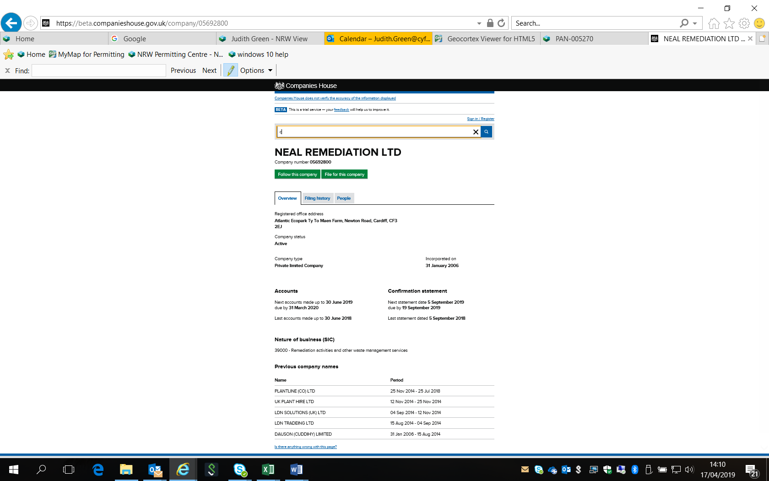

Neal Remediation Ltd.

Companies House registration number 05692800

5 current officers

NEAL, Liam David
Correspondence address
48 Heol Y Nant, Rhiwbina, Cardiff, Wales, CF14 6BT
Role Active
Secretary
Appointed on
5 September 2014

EVANS, Darren
Correspondence address
Atlantic Ecopark, Ty To Maen Farm, Newton Road, Cardiff, CF3 2EJ
Role Active
Director
Date of birth
April 1970
Appointed on
15 August 2018
Nationality
British
Country of residence
Wales
Occupation
Director

KENNEY, Michael Andrew
Correspondence address
Atlantic Ecopark, Ty To Maen Farm, Newton Road, Cardiff, CF3 2EJ
Role Active
Director
Date of birth
May 1947
Appointed on
15 August 2018
Nationality
British
Country of residence
Wales
Occupation
Director

NEAL, David John
Correspondence address
Atlantic Ecopark, Ty To Maen Farm, Newton Road, Cardiff, CF3 2EJ
Role Active
Director
Date of birth
July 1960
Appointed on
15 August 2018
Nationality
British
Country of residence
Wales
Occupation
Director

NEAL, Liam David
Correspondence address
48 Heol Y Nant, Rhiwbina, Cardiff, Wales, CF14 6BT
Role Active
Director
Date of birth
June 1986
Appointed on
5 September 2014
Nationality
British
Country of residence
United Kingdom
Occupation
Company Director

