Permit
The Environmental Permitting (England & Wales) Regulations 2010

Energy Pyrolysis Limited

Energy Pyrolysis
Penyrheol Sidings
St Cenydd Road
Caerphilly
CF83 2RP

Permit number

EPR/AB3391HB

Permit
The Environmental Permitting (England and Wales) Regulations 2010
Permit number

EPR/AB3391HB

The Natural Resources Body for Wales (“Natural Resources Wales”) authorises, under regulation 13 of the Environmental Permitting (England and Wales) Regulations 2010

Energy Pyrolysis Limited (“the operator”),

whose registered office is

Suite 109

Raydean House

15 Western Parade

Barnet

Hertfordshire

EN15 1AH

company registration number 08679077

to operate waste operations at

Energy Pyrolysis

Penyrheol Sidings

St Cenydd Road

Caerphilly

CF83 2RP

to the extent authorised by and subject to the conditions of this permit.

Under regulation 27(2) of the Regulations, standard rules SR2008No25 are conditions of this permit.

Name | Date
Holly Noble | 15/12/2016

Authorised on behalf of Natural Resources Wales

Schedule1 – Site Plan

This is the plan referred to in the standard rules SR2008 No25

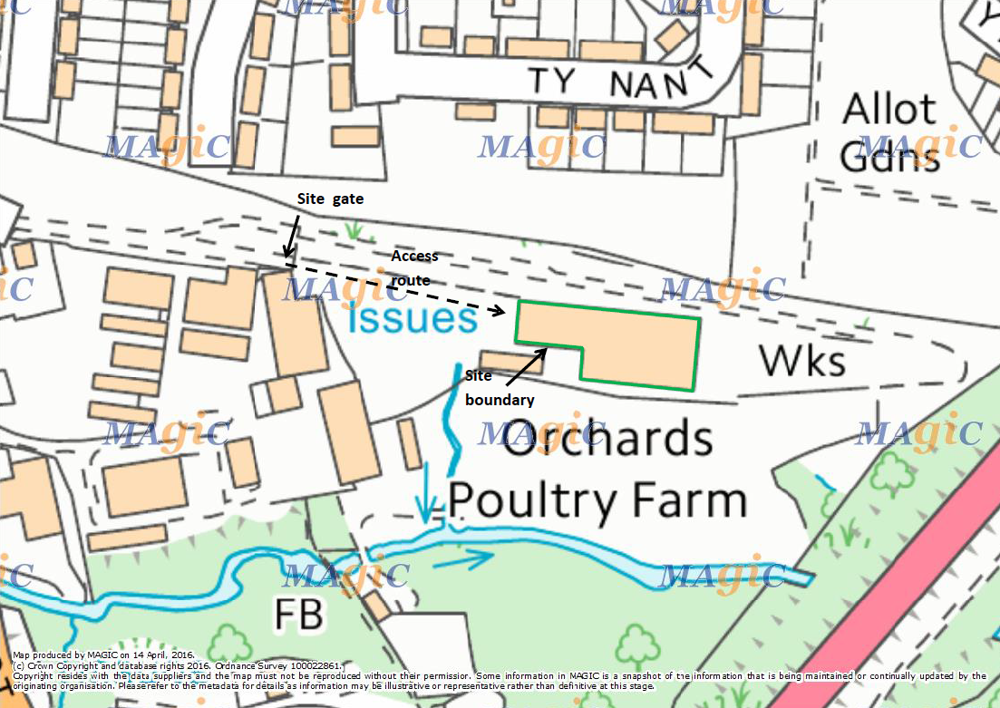

© Crown Copyright and database right 2016. Ordnance Survey licence number 100019741

END OF PERMIT

