Permit
The Environmental Permitting (England & Wales) Regulations 2016

Mr Gareth Lloyd Davies
& Mr Arwyn Lloyd Davies
Davies Motors
Mill Garages
Betws Gwerfil Goch
Corwen
LL21 9PU

Permit number

EPR/CB3197HF

Permit
The Environmental Permitting (England and Wales) Regulations 2016
Permit number

EPR/CB3197HF
The Natural Resources Body for Wales (“Natural Resources Wales”) authorises, under regulation 13 of the Environmental Permitting (England and Wales) Regulations 2016

Mr Gareth Lloyd Davies & Mr Arwyn Lloyd Davies,

Unit 47
Lon Parcwr
Ruthin
Denbighshire
LL15 1LY

to operate waste operations at

Davies Motors

Mill Garages
Betws Gwerfil Goch
Corwen
LL21 9PU

to the extent authorised by and subject to the conditions of this permit.

Under regulation 27(2) of the Regulations, standard rules SR2011 No3 are conditions of this permit.

Name | Date
Huw Davies | 14/07/2021

Authorised on behalf of Natural Resources Wales

Schedule 1 - Site plan

This is the plan referred to in the standard rules SR2011 No3
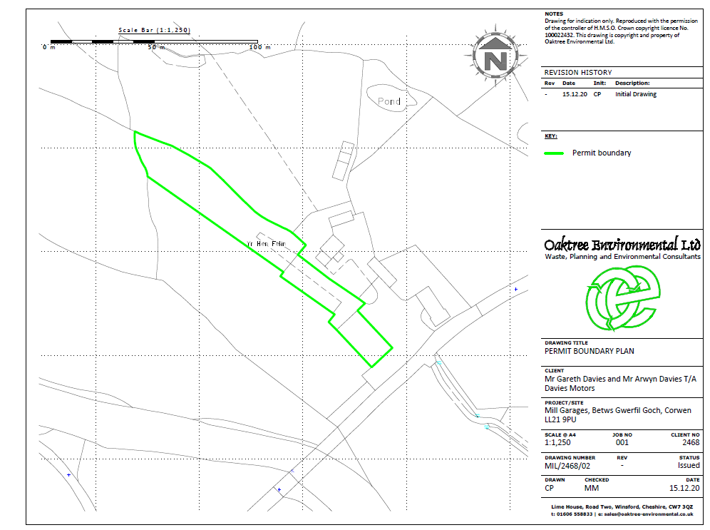

END OF PERMIT

