Rheidol Recycling Park Audit Report


The audit was conducted by Malcolm Dines (Lead Auditor) and Callum Stone in the presence of Mr. Leon Gobourn (Operator) and Peter Malvern (Site Manager).

Technical Competence
Peter Malvern is the Technically Competent Manager (TCM) for the site, his award details are: 4MPTH – Managing Physical & Chemical Treatment Hazardous Waste; Certificate number: OCC4203. Provided by C&G; Gained: 03/10/2013 and valid to: 03/10/2015
Leon Gobourn was previously listed as a TCM for the site however, the continuing competency certificate held by Mr Gobourn lapsed as of the 28th Feb 2014. Should Mr Gobourn wish to continue to act as a Technically Competent Manager he will need to pass a relevant Continuing Competency assessment.
To meet the requirements for Technically Competence provision, a suitably qualified person must be on-site for 20% of the time that the site is open, this equates to 11 hours a week, which is met by Peter Malvern. However the operator was relying on signed weighbridge tickets signed by himself as evidence of attendance on-site. This is not sufficient and there should be accurate records of the TCM signing in and out of the site, so recording time present on-site.

Wood Waste
All of the wood waste accepted at the site came from within Ceredigion, from civic amenity (CA) sites, waste transfer stations and in mixed construction waste. The wood is stored in an exposed open bay draining to sealed drainage. Once sorted, graded and shredded, it is transferred to a number of sites for recycling or repurposing, with Hadfield Wood Recycling and The Stobart Group being the main recipients. Clean untreated wood and wooden pallets are sorted on site, the cleanest pallets are resold and/or repurposed.
Up until recently, UPM Shotton was a client, but has since ceased to accept waste wood, creating a minor but manageable backlog of waste.
At the time of the audit there was more wood waste on-site than the storage bay could hold and had spilled into the yard where drainage was provided by surface water only. Despite this, during the visit, a large amount of wood waste was delivered from a CA site. The operator stated that this overspill was caused partly by the backlog of wood waste, but also that once sorted and chipped it would be condensed. As the audit was taking place, the waste began to be graded, separating higher quality wood that can be reused from lower quality waste. The storage of wood on an area leading to surface water draining is a breach of permit condition 1.1.1 as non-hazardous waste must be stored on an impermeable pavement with sealed draining and can only be bulked and transferred within a building. This breach receives a CCS score of 3.
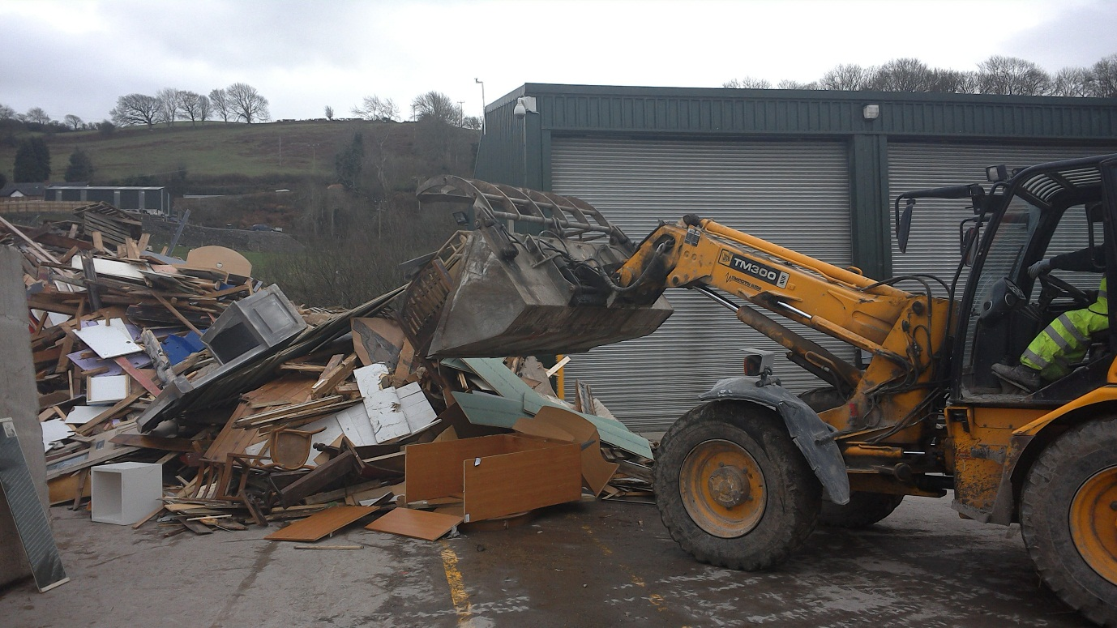

It was identified that wood waste was leaving the site under the EWC code 17-02-01, however the correct code for it would have been 19-12-07 as it has been mechanically treated on site. For the purpose of traceability, the operator was purposefully using an incorrect EWC code to be able to trace where wood waste was being sent to, for example one EWC code would be used for wood going for recycling, whilst another was being used for wood going for use in energy production in biomass burners despite both being the same waste type. The operator was advised that this was not acceptable as the EWC Codes describe the waste and they would have to implement a system whereby all outgoing waste of the same EWC can be traced and differentiated.

Site Waste Returns
Site Waste Returns for 2013 and 2014 were reviewed to ensure compliance with permitted waste quantities and waste types. The reported quantities of waste accepted at the site was within permitted quantities, however several non-permitted waste types were reported as being accepted: EWC codes 15-01-07; 19-12-02; 20-01-10; 20-01-11; 20-01-27; 17-03-02

EWC 15-01-07: Glass Packaging
The operator accepts waste glass on to the site under the EWC code of 15-01-07, which is not a permitted waste type for the site. Further to not being allowed to be accepted on site the only glass that could be accepted under a 15 code must come from a commercial source where it can be confirmed as purely being packaging. Waste sourced from municipal sites, or mixed sources must be coded as 20-01-02 due to be unable to separate packaging glass such as bottles and jars from other glass such as drinks glasses.
EWC 17-03-02: Bituminous Mix
Over 600 tonnes of bituminous mix has been accepted at the site since the beginning of 2013 despite the EWC code not being allowed by their permit. The operator stated that it was their belief that the material they accepted, road planings, did not contain bitumen and that the EWC code was the most accurate description for the waste as there was no other category it could fit within. As this is not an inert waste and it was not stored on an impermeable pavement with sealed drainage, this is a breach of permit condition 2.1.1 and receives a CCS 3 score. As this breach is the same CAR criteria as the breach for Wood waste being stored on an area served by surface water drains, these scores are consolidated as one breach. Bituminous wastes will, however, come under the operator’s new permit which was not yet in place at the time of the audit.
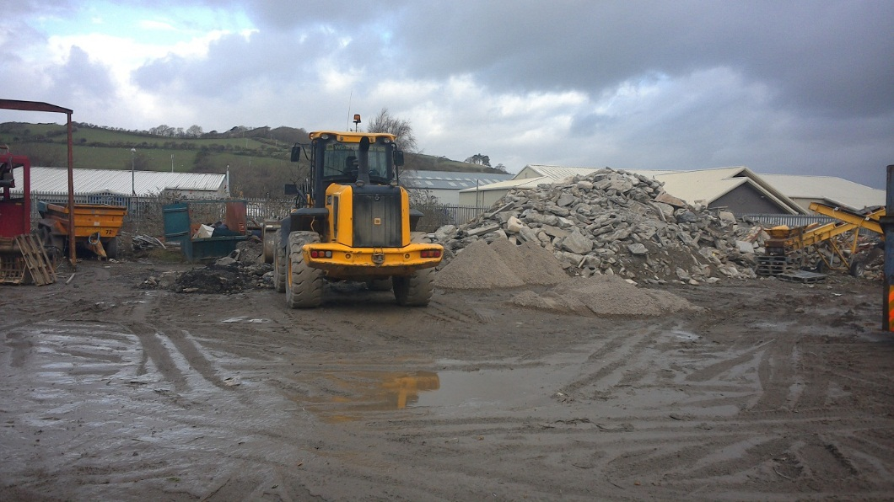
EWC 19-12-02: Ferrous Metals
The operator has accepted waste metal under the EWC code 19-12-02, which is not allowed under this permit., This code refers specifically to waste metals that have been mechanically treated and during the audit it was identified that the waste had come from a source where it had not been mechanically treated and would have been better suited to the EWC code of 20-01-40.
EWC 20-01-10; 20-01-11 & 20-01-27: Clothes; Textiles & Paints and Inks
Clothes, textiles, paints and inks had been recorded as having been accepted by the site in quarterly waste returns, however, the case was that waste with these codes was being brought from another site to only be weighed, and then taken on for disposal elsewhere. It was advised that in future, items only being weighed but not processed on site would not need to be included in returns as the material is not being deposited at the site. The vehicles are using the weighbridge as a standalone service

Site Waste Returns
While carrying out the audit, it was identified that there was a large amount of waste which was being stored outside the permitted area. Green waste, WEEE and some scrap metal was being stored on impermeable pavement with sealed drainage. Plastics and other scrap metal were being stored on hard-standing.
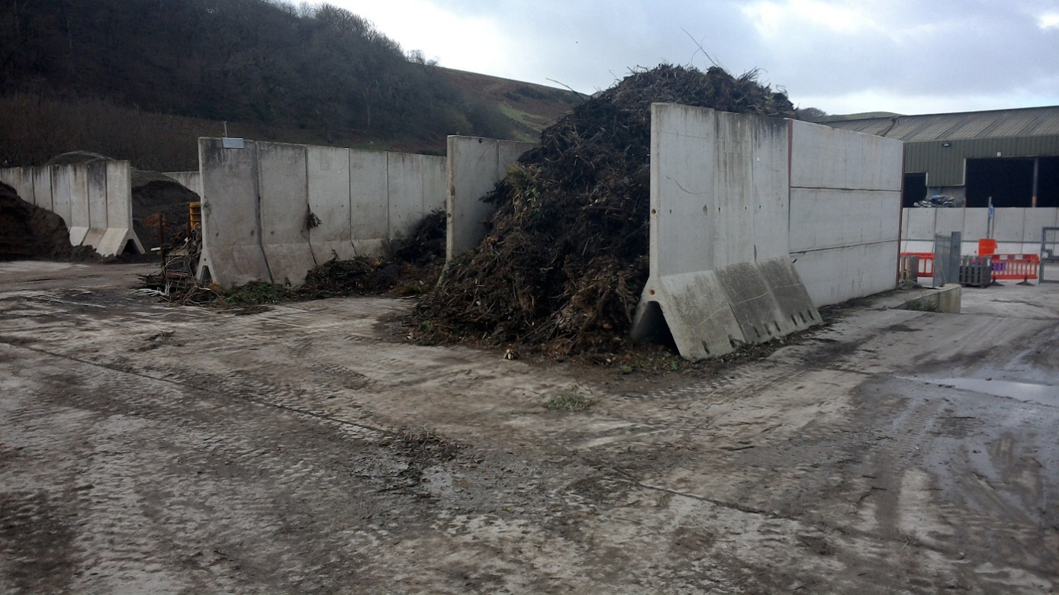

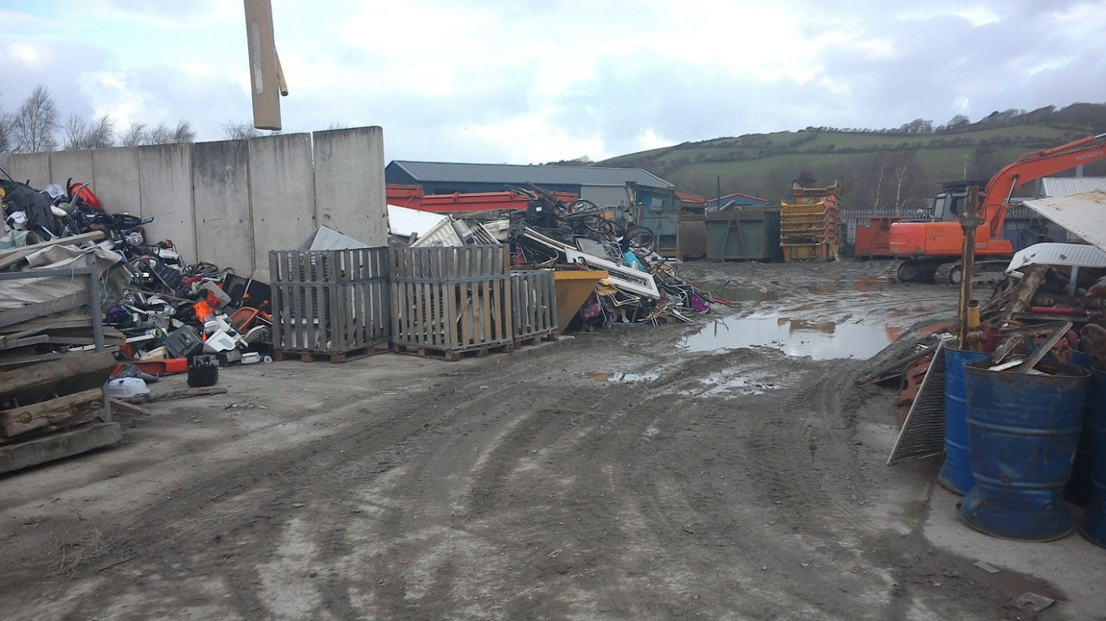
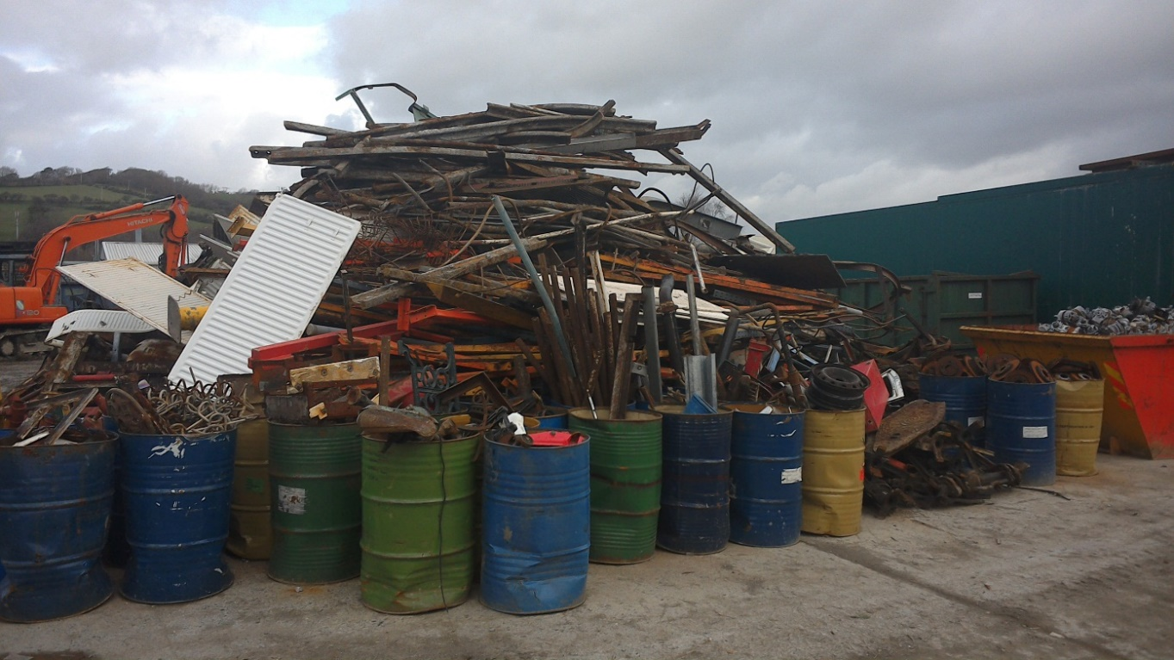

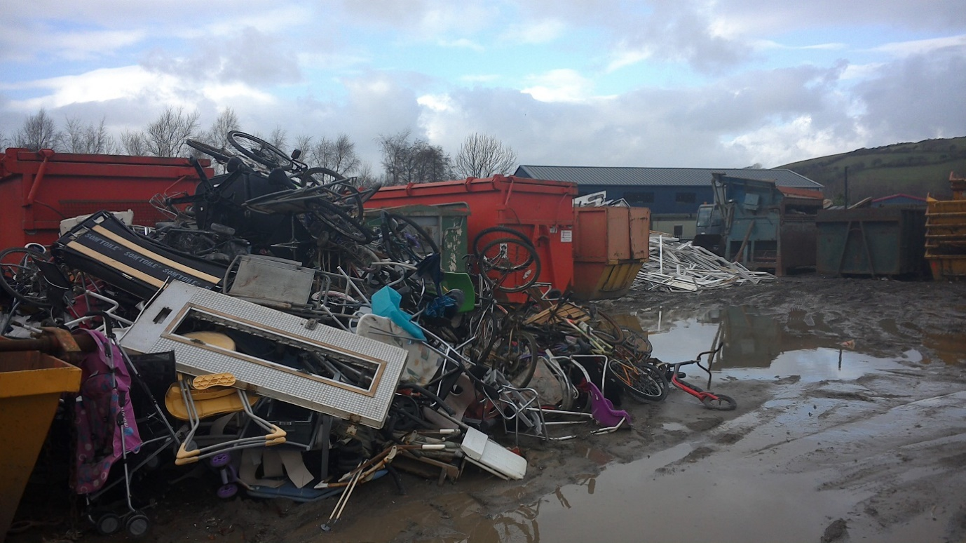
The Site Manager explained that their permit variation was due to be issued imminently and in the process of re-organising the site prior to receiving the new permit they had needed additional space to store wastes. Storing wastes outside the permitted area is a breach of the permit. The compliance score for this breach is consolidated in the section below relating to the Environmental Management System.

Environment Management System
The root-cause of the acceptance of non-permitted waste types, storing wastes outside the permitted area, whilst incorrect use of EWC codes and insufficient recording of TCM attendance is due to a failing in the Environmental Management System at the site. Although the EMS was not reviewed on-site, these breaches would not have occurred if site was being operated in accordance with an EMS that identifies and minimises the risk of pollution. This is a breach of permit condition 1.1.1 and receives a CCS 3 score.
The EMS should not allow wastes to be described as something they aren’t purely to facilitate internal tracking. This could result in an inability to accurately audit waste movements and could result in permit breaches by those operators receiving incorrectly identified waste.
The operator should ensure that their EMS is kept up-to-date, is accessible to all people working on site who need to refer to it and that it is adhered to by site operatives.
Site management should also ensure that waste returns are reviewed and non-permitted waste types identified and a corrective measure implemented prior to submission of site waste returns.
Staff who are required to report and use EWC codes should be adequately trained so that they can correctly use the codes.

Permit Variation
Since the audit, a permit variation for the site has been issued that addresses most of the breaches identified during this audit, including waste being stored outside the permitted area.

Separate Waste Collections
Although outside the remit of a compliance audit, the requirements of the Separate Collection Regulations were discussed with the operator. As of the 1st of Jan 2015, all waste operators will be required by law to provide a separate waste collection service for dry recyclate. This is to ensure that household and similar metals, paper, glass and plastics are collected separately from residual wastes. Whilst the onus is on the operator to provide this service, and not the client to use it, the operator raised the issue of when dealing with smaller sites where space to house enough skips becomes an issue. For administrative purposes, it was suggested during the audit that the operator keeps a written record of having provided this service, whether it has been used or not by the client.

