CRoW Appendix 4 (140_10_SD02)  CRoW Act 2000: Natural Resources Wales application for permission - Formal Notice |  | 
Natural Resources Wales Formal Notice.
Requirements of Section 28I of the Wildlife & Countryside Act 1981 as amended by the Countryside and Rights of Way Act (CRoW) 2000.
Duty in relation to granting any consent, licence or permit for activities likely to damage Sites of Special Scientific Interest (SSSI).
Guide to filling in this form for Natural Resources Wales staff:
To be completed by Permitting Officers for any applications for a permission which the Natural Resources Wales has considered under S28G duties to protect and enhance SSSIs. This applies to all proposed permissions within a SSSI, and to operations outside the SSSI boundary which are likely to damage its special features.
Refer to OI 140_10 ‘Applying the Countryside and Rights of Way (CRoW) Act 2000 to applications for permits with potential for impact on Sites of Special Scientific Interest (SSSI)’, including the flowchart in Appendix 2.
Pink italic text – drafting notes, to be deleted before completion/consultation.
Blue text – examples, to be replaced with permission-specific information.
Ensure you have completed all sections.
- Natural Resources Wales area/region/NPS hub: | Flintshire & Wrexham – Environment team
- Name of SSSI: | Sites of Special Scientific Interest (SSSIs) within 2km of the installation.  - Llay Bog SSSI  - Vicarage Moss SSSI in absence of APIS information on Midland Meres & Mosses Phase 2 RAMSAR
- Type of permission: | Environmental Permit Application – Complex Bespoke Application
- Date for Natural Resources Wales permit determination:
- Predicted 28 day date for response from NRW conservation/ecology (under S28 I(4)): | 28 days: 09/05/2022
- Natural Resources Wales reference no: | PAN-016681
- National grid reference: | The Site is located at SJ 31988 56245.  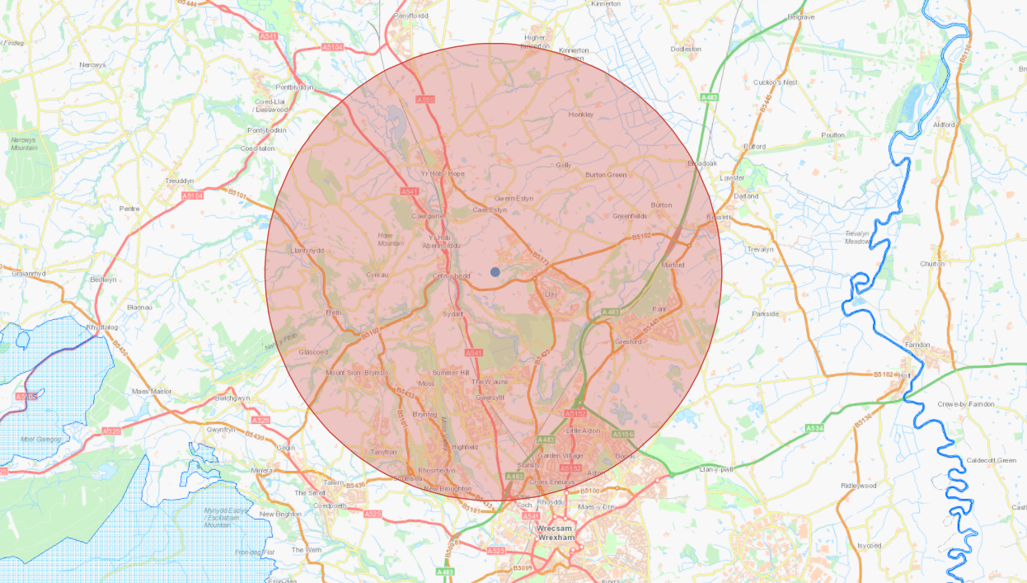
- Description of proposal: | The site is on brownfield land previously used in association with mining activities, covered in hardstanding, at Llay Hall Farm, Llay, Wrexham, LL12 0PD. The Site is surrounded predominately by commercial and industrial use.  The site comprises of 2 natural gas fired engines totalling a net thermal input of 8.7MWth , 1x 3.6 MWth and 1x 5.1 MWth. Detailed air dispersion modelling has been used to assess the impacts on local air quality for 8760 hours of operation per annum (maximum operation hours per year) at ecological receptors within 2km (relevant screening distance of the installation).  The operational hours will be limited to 8760 hours per year in the permit.
- Is the proposed activity within (wholly or partially) the SSSI boundary? | NO
- Has there been any pre-application discussion or correspondence with NRW conservation/ecology | YES  Question: Is using Vicarages Moss SSSI CLe & CLo data as a substitute for Midland Meres & Mosses Phase 2 RAMSAR the right approach to use given missing data on APIS.  Response: The approach is sound in the absence of APIS info for the RAMSAR in using the CL levels for the fen feature at Vicarage Moss which corresponds with the RAMSAR feature.
- What aspect(s) of the proposed permission may damage the features which are of special interest for the SSSI?
The following ‘Operations Requiring Consent’ (or other activities associated with the permission) that may cause damage) are relevant to the proposed permission.

- The key pollutants considered in this assessment are oxides of nitrogen (NOx as NO2), the primary pollutants arising from the combustion of natural gas. Other pollutants, such as sulphur dioxide (SO2) and particulate matter (PM10) are generated in negligible levels when using natural gas as the fuel. Carbon monoxide (CO) is not relevant for ecological assessment.

The following SSSI features and mechanisms of impact have been considered to assess the likelihood of damage:
- Potential for increased Toxic contamination, Nutrient enrichment and Acidification.

Site Features

Llay Bog Site of Special Scientific Interest – Your Special Site and its Future
- Wet woodland
- A mosaic of bog habitats

Llay Bog Site of Special Scientific Interest – Your Special Site and its Future
- Pleistocene/Quaternary landform assemblage (kettle holes) and associated sediment deposits.
- A Mixture of Mire, Swamp, Wetland and Wet Woodland plant communities.

- Decision

The applicant has submitted computer modelling to assess the impact of NOx and nitrogen also acid deposition at ecological receptors within 2km of the installation at Llay Power Plant. The modelling quantifies and assessed the potential air quality impacts associated with combustion emissions from Llay Power Plant using NRW techniques against published standards for the protection of human health and designated ecological sites.

Comparison against critical levels and loads:
The process contribution from the installation has been calculated and compared against the minimum and maximum critical levels and loads for each habitat type found within the SSSI. The results for the SSSI are as follows:
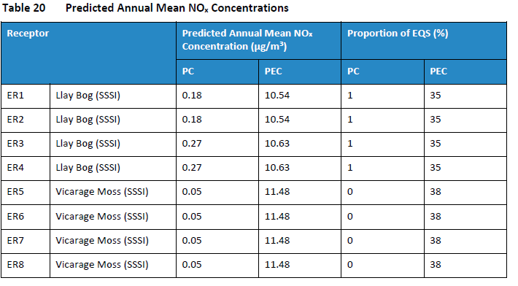
Llay Bog NOx Annual
The maximum long-term process contribution (PC) is 0.27 µg/m³ and is <1% of the long-term critical level. The annual impact from NOx emissions can be screened out as insignificant.

Vicarage Moss NOx Annual
The maximum long-term process contribution (PC) is 0.05 µg/m³ and is <1% of the long-term critical level. The annual impact from NOx emissions can be screened out as insignificant.
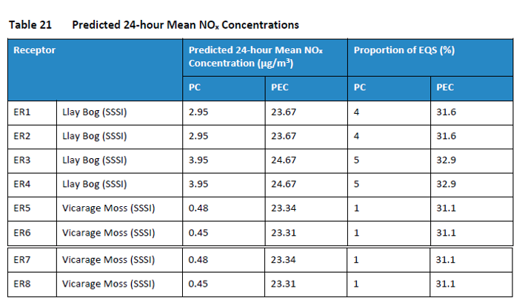
Llay Bog NOx Daily
The maximum short-term (PC) is 3.95 µg/m³ and is <10% of the short-term critical level. The daily impact from NOx emissions can be screened out as insignificant.

Vicarage Moss NOx Daily
The maximum short-term (PC) is 0.48 µg/m³ and is <10% of the short-term critical level. The daily impact from NOx emissions can be screened out as insignificant.

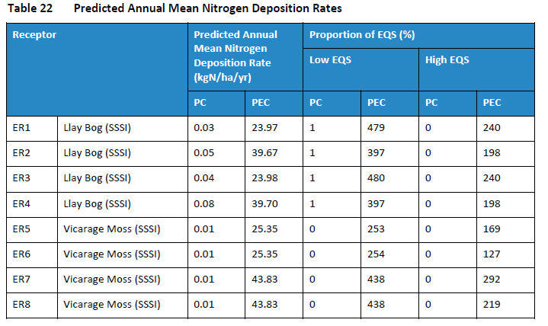
Llay Bog Nitrogen Deposition
The maximum nitrogen deposition PC is 0.08 kgN/ha/yr and is <1% of the critical load value, when using a conservative critical load of 5 kgN/ha/yr. The impact from nitrogen enrichment can be screened out as insignificant.

Vicarage Moss Nitrogen Deposition
The maximum nitrogen deposition PC is 0.01 kgN/ha/yr and is <1% of the critical load value, when using a conservative critical load of 5 kgN/ha/yr. The impact from nitrogen enrichment can be screened out as insignificant.
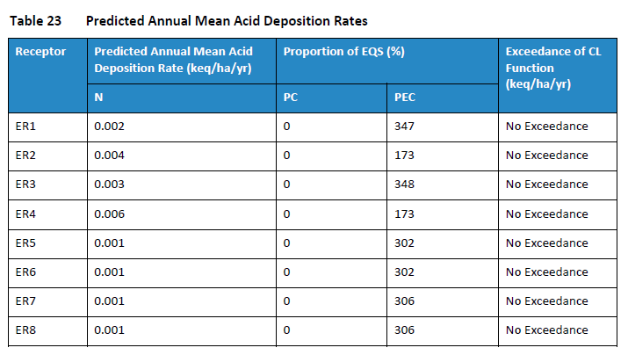
Llay Bog (ER1-ER4) Acid Deposition
A maximum acid critical load value of 1.838 CLmaxN k_{eq}/ha/yr has been assumed for the Llay Bog. The acid PC is 0.006 k_{eq}/ha/yr and is <1% of the acid critical load. The impacts of acidification can be screened out as insignificant.

Vicarage Moss (ER5-ER8) Acid Deposition
A maximum acid critical load value of 1.117 CLmaxN k_{eq}/ha/yr has been assumed for the Vicarage Moss. The acid PC is 0.001 k_{eq}/ha/yr and is <1% of the acid critical load. The impacts of acidification can be screened out as insignificant.

Conclusion
- The predicted process contribution does not lead to any exceedances at any sensitive ecological receptor for the impact of NOx, nutrient enrichment or acidification therefore, the proposed impact from the installation’s operations can be screened out as insignificant.

- The operational hours will be determined by grid balancing requirements (anticipated to ~ 2,500 hours per year). However, given the variability in operating hours, as a precautionary approach, it has been assumed that the generators will operate 8,760 hours per year (i.e. continuously).

- This modelling report is very conservative and has been greatly over estimated, therefore the impact of this installation is not likely to have a significant effect on the modelled ecological receptor.

i) The proposed permission is not likely to damage any of the flora, fauna or geological or physiological features which are of special interest.

Natural Resources Wales is minded to:
Issue the permission

- Name and job title of Natural Resources Wales officer: | Lewis Downey - Permitting Officer, Installations and RSR
- Date form sent to NRW conservation/ecology | 11/04/2022
For Natural Resources Wales use only, once NRW conservation/ecology response received
- NRW conservation/ecology comment on assessment: | Please delete as appropriate:  i) NRW conservation/ecology advise the operation can go ahead  ii) NRW conservation/ecology advise the operation can go ahead with conditions  iii) NRW conservation/ecology advise against permitting the operation  Please ensure that the NRW conservation/ecology response is attached to this Formal Notice.
- Name and job title of NRW conservation/ecology officer:
- Date of receipt of NRW conservation/ecology response:

