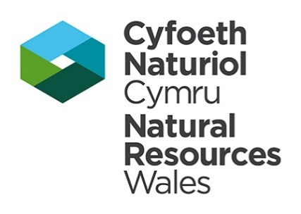

Company Secretary Our ref: PAN-006045
JM Envirofuels (Barry) Limited
Meriden House
6 Great Cornbow
Halesowen Date: 23 July 2020
West Midlands
B63 3AB

Dear Company Secretary,
Notice of deemed withdrawal
Application reference: PAN-006045
Operator: J M Envirofuels (Barry) Limited
Facility: J M Envirofuels (Barry) Limited, Berth 31 Wimborne Road, Barry Docks, Barry, CF63 3DH

I enclose a notice informing you that your application is deemed withdrawn because of your failure to comply with the Schedule 5 notice dated 24 April 2020.
As a result of the deemed withdrawal no further work will be carried out in relation to your application. In these circumstances the fees that you paid to the Natural Resources Body for Wales (“Natural Resources Wales”) are non-refundable.
Rights of appeal
If you are not happy with our decision to deem withdrawal you may appeal to the Welsh Ministers. You must make your appeal by 13/08/2020.
Further information about making an appeal and the forms you will need are available from the contact details below.
The Planning Inspectorate, Crown Buildings, Cathays Park, Cardiff, CF10 3NQ. Phone: 029 2082 3866 / 389, Fax: 029 2082 5150, Email: wales@pins.gsi.gov.uk
You must send written notice of the appeal and the documents listed below to the Welsh Ministers address at the address given above. At the same time you must send us a copy of the notice and documents.
The documents are:
a statement of the grounds of appeal;
a copy of any relevant application;
a copy of any relevant environmental permit;
a copy of any relevant correspondence between the appellant and the regulator;
a copy of any decision or notice which is the subject matter of the appeal; and
a statement indicating whether you wish the appeal to be in the form of a hearing or dealt with by way of written representations.

You may withdraw an appeal by notifying the Welsh Ministers in writing and sending a copy of that notification to us.
If you have any questions in relation to the Notice please email waste.permittingenquiries@naturalresourceswales.gov.uk

Yours sincerely,
Kate Thomas
Lead Specialist Officer – Waste Permitting

Cc: Mr Alan Webb

