Morlais Project

Document MOR/RHDHV/DOC/0072 (10):
Outline Environmental Mitigation and Monitoring Plan

Outline Adaptive Management Approach to Environmental Mitigation and Monitoring during the Phased Deployment of the Morlais Project

Applicant: Menter Môn Morlais Limited
Document Reference: PB5034-ES-EMMP
Document MOR/RHDHV/DOC/0072 (10): Outline Environment Mitigation and Monitoring Plan
Authors: Royal HaskoningDHV
Morlais Document No.:  MDZ/A24.4 - MMC447(4) - MOR/RHDHV/DOC/0072 (10) | Status:  Revised - Final | Version No:  F10.0 | Date:  14/06/2021

© 2021 Menter Môn This document is issued and controlled by:
Morlais, Menter Mon. Registered Address: Llangefni Town Hall, Anglesey, Wales, LL77 7LR, UK
Unauthorised copies of this document are NOT to be made
Company registration No: 03160233 Requests for additional copies shall be made to Morlais Project
TABLE OF CONTENTS
TABLE of TAbles iii
TABLE of Plates iii
Glossary of Abbreviations iv
Summary of key changes to outline EMMP since initial submission iv
1. Introduction 1
1.1. Purpose of this Document 2
1.2. The Need for an EMMP 6
1.3. Key principles underpinning the EMMP 7
2. The Environmental Mitigation and Monitoring Plan Process 16
2.1. Outline Terms of reference of the EMMP 16
2.2. Outline Aims and objectives of the EMMP 16
2.3. EMMP Process 18
2.4. EMMP Compliance 19
2.5. Collision Decision Framework and Trigger points 20
2.6. Monitoring and Reporting 23
2.7. Outline Monitoring Indicators 24
2.8. Outline Monitoring Questions 26
3. EMMP Roles and Responsibilities 27
3.1. Ownership of the EMMP 27
3.2. Role of the regulators in the Advisory group 27
3.3. Appointment and role of the Advisory Group 28
3.4. Governance 29
3.5. Meetings and reporting 29
3.6. Emergency Response 29
4. Outline Approach to Mitigation and Monitoring Methods 30
4.1. Mitigation 30
4.2. Monitoring 31
5. Outline schedule of EMMP Tasks 40
6. Summary of Outline Approach 43
6.1. Marine Mammals 43
6.2. Diving Seabirds 44
6.3. Migratory Fish 44
7. References 45
8. Appendix 1. Consent condition examples 46
8.1. MeyGen - Tidal stream project - example consent conditions 46
8.2. Beatrice offshore wind farm – example consent condition 46
9. Appendix 2 Advisory Group Terms of Reference example 47
10. Appendix 3. Phased deployment – example 51

TABLE of TAbles
Table 1-1 Illustration of potential use of proximity trigger points 14
Table 2-1 Outline Monitoring Indicators 24
Table 2-2 Outline Monitoring Questions 26
Table 4-1 Review of Potential Monitoring and Mitigation Methods 33
Table 5-1 EMMP Outline Post Consent Schedule of Tasks 40

TABLE of Plates
Plate 2-1 Illustration of proposed EMMP process for initial deployment and repowering 21
Plate 2-2 Illustration of proposed outline noise modelling and monitoring process within the EMMP 22
Plate 2-3 Illustration of proposed collision or incident decision framework (from NRW, 2020¹). The figure outlines the decision-making stages when collisions are detected, and subsequent mitigation and reporting requirements 23

Glossary of Abbreviations
ADD | Acoustic Deterrent Device
CEMP | Construction Environmental Management Plan
ECC | Export Cable Corridor
EMMP | Environmental Mitigation and Monitoring Plan
ES | Environmental Statement
HDD | Horizontal Directional Drilling
JNCC | Joint Nature Conservation Committee
MDZ | Morlais Demonstration Zone
ML | Marine Licence
MMMP | Marine Mammal Mitigation Protocol
MW | Megawatt
NRW | Natural Resources Wales
ODA | Onshore Development Area
PBR | Potential Biological Removal
PTS | Permanent Threshold Shift
RSPB | Royal Society for the Protection of Birds
SAC | Special Area of Conservation
TWAO | Transport and Works Act Order
UK | United Kingdom

Summary of key changes to outline EMMP since initial submission

Location | Change
Section 1 | Recent advice on adaptive management of collision risk for marine mammals.
Section 1 Para 7 | Clarification that the constraint on scale applies to all phases including the first phase.
Section 1 Para 27 | Clarification that underwater noise will be modelled, monitored and mitigated
Section 1 Para 28 | Reference to draft ML condition now at Appendix 4
Section 1 Para 30 | Clarification that purpose of the OEMMP includes monitoring and mitigation of potentially significant effects on seabirds
Section 1 Para 39 | Clarification that it is the applicants proposal to remove monitoring and mitigation as soon as and if the Regulator agreed it was appropriate to do so
Section 1 Para 46 | Clarification that the worst case scenario will be assumed as the species with the lowest or nearest the collision limit
Section 1 Para 71 | Correct typo to correct distance as in Table 1-1
Section 1 | Recent advice on inclusion of monitoring of migratory fish within the EMMP.
Section 1.1 | NRW advice on membership of an Advisory Group for adaptive management of a marine project.
Section 1.1 | Commitment to inclusion of migratory fish monitoring within the EMMP.
Section 1.1. | Commitment to include mitigation and monitoring of underwater noise impacts and potential barrier effects on marine mammals in the EMMP
Section 1.1 | Commitment to ensure that underwater noise from operational turbines will not result in the significant disturbance of marine mammals.
Section 1.1 | Commitment to ensure that underwater noise from acoustic deterrent devices will not result in the significant disturbance of marine mammals.
Section 1.3.1 | Potential scale of Phase 1 in terms of MW and numbers of devices.
Section 1.3.1 | Role of PBR in definition of deployment phase 1.
Section 1.3.1 | Applicant’s intention to remove monitoring and mitigation requirements as soon as evidence gained from the EMMP shows that it is appropriate to do so, with agreement of Regulators.
Section 1.3.2 | Commitment to use of adaptive management through implementation of the EMMP.
Section 1.3.2 | Inclusion of a collision incident decision framework within the outline EMMP.
Section 1.3.3 | Agreed species collision limits.
Section 1.3.4 | Commitment to underwater noise modelling and monitoring.
Section 1.3.4 | Details of approach to modelling proposed.
Section 1.3.5 | Monitoring commitments.
Section 1.3.6 | Inclusion of noise in consideration of mitigation.
Section 1.3.7 | Commitment to establishment of collision decision framework.
Section 1.3.8 | Consideration of proximity trigger points.
Section 1.3.8 | Inclusion of noise within consideration of trigger points.
Table 1-1 | Consideration of management actions associated with trigger points by species / species group.
Plate 2-1 | Revised illustration of the proposed EMMP process, with greater detail regarding those parts of the process pre deployment, when scale of initial deployment is agreed.
Plate 2-2 | Addition of illustration showing the proposed EMMP process for noise modelling and monitoring.
Plate 2-3 | Addition of illustration showing the proposed EMMP process for management of emergency incidents, such as marine mammal collision.
Section 2.1 | Addition of proposed terms of reference for the operation of the EMMP.
Section 2.1 | Inclusion of migratory fish in terms of reference.
Plate 2-3 | Insertion of new figure from NRW advice.
Section 2.2 | Further consideration of outline EMMP aims and objectives.
Section 2.3.1 | Clarification for activities pre-or within 6 months of consent
Section 2.6 | Commitment to real time monitoring and reporting.
Table 2-1 | Inclusion of migratory fish.
Table 2-2 | Inclusion of migratory fish.
Section 3.2 | Relationship between Regulator and Advisory Group.
Section 4 | Further consideration of mitigation measures and monitoring methods proposed, including consideration of the capacity for real time monitoring and recorded monitoring, where appropriate.
Section 4.1 | Commitment to mitigation in alignment with NRW advice.
Section 4.1.2 | Clarification that passive deterrence will be without significant disturbance effects.
Section 4.2.1 | Inclusion of mitigation methods.
 | Explicit inclusion of mitigation in title and table heading.
Section 4.2 Para 147 | Clarification on underwater noise monitoring and potential mitigations
Section 4.2 Para 149 | Clarification that EMMP is open to considering all monitoring technologies including new and developing technologies
Table 4-1 | Removal of references to considered / not considered as all technologies are open for consideration
Table 4-1 | Addition of underwater noise monitoring
Table 4-1 | Revision of the suite of monitoring and mitigation measures identified a potentially available to the EMMP, to include consideration of real time monitoring applicability, and suitability for the monitoring of mitigation efficacy.
Table 4-1 | Potential use of acoustic deterrence for diving birds added.
Table 4-1 | Inclusion of migratory fish.
Table 4-1 | Removal of reference to visibility in the MDZ
Table 5-1 | Clarification for activities pre-or within 6 months of consent
Section 6 para 163 | Clarification that monitoring will be used to assess disturbance from underwater noise
Section 6.3 | Addition of migratory fish summary.
Appendix 1 | Example consent conditions – demonstrating mechanism for enforcement of environmental management and monitoring used by UK regulators for tidal stream and offshore wind projects.
Appendix 2 | Example terms of reference developed by developer with UK Regulators for the operation of an equivalent mechanism to the EMMP.
Throughout | Clarification of outline and detailed stages of the EMMP.
Appendix 4 | Inclusion of Draft EMMP Marine Licence condition (36)

Introduction
- This document is an outline Environmental Mitigation and Monitoring Plan (EMMP) for the Morlais Project. This document is provided pre-consent, and in an outline form, as a demonstration of the commitment of the Morlais Project to the development of a detailed EMMP as a condition of consent.
- The outline EMMP incorporates the recent advice from Natural Resources Wales (NRW, 2020)¹ on adaptive management of the risk of collision impacts on protected marine mammal species in Welsh waters from the Morlais Project.
- This outline EMMP also incorporates recent advice by NRW that monitoring for migratory fish should be included within the EMMP. Note that this has been incorporated within an addendum to information to support Habitats Regulation Appraisal (HRA) for the project (MMC351).
- Menter Môn Morlais Limited (‘the applicant’, hereafter referred to as Menter Môn or the Applicant) is seeking consent via a Transport and Works Act Order (TWAO) and Marine Licence (ML) for the Morlais Project (hereafter ‘the Project’).
- Menter Môn is committed to safeguarding the environment through the identification, avoidance and mitigation of potential adverse environmental impacts associated with the construction, operation and decommissioning of the Project, including, but not limited to collision risk of diving seabirds and marine mammals with operational turbines, disturbance or displacement as a result of underwater noise and any potential barrier effects as a result of the physical presence of the array or underwater noise.
- The Project is described in Chapter 4, Project Description of the Environmental Statement (ES), prepared to support consent applications for the Project. In summary, the Project consists of three distinct areas within which components of the Project will be installed, as follows:
- The Morlais Demonstration Zone (MDZ), within which arrays of tidal devices will be deployed (deployment will be in a series of phases (see Section 1.3.1) up to a maximum installed capacity of 240 MW) and associated infrastructure such as foundations, array hubs, inter array cables, cable protection and other associated infrastructure, will be deployed.
- The Export Cable Corridor (ECC), within which up to nine export cables and associated cable protection will be laid. The ECC also includes the intertidal area, where the export cables will make landfall via either horizontal directional drilling (HDD) or trenching.
- The Onshore Development Area (ODA) shares the export cable landfall with the ECC, with export cables then passing to a landfall substation, and from there via an onshore cable route to a grid substation and connection to grid.
- Device deployments in all Phases including Phase 1 will only be allowed at scales at which Regulators agree that the best available scientific understanding does not predict adverse impacts upon marine mammals or upon non SPA populations of diving seabirds from local colonies.
- No device operation will be allowed until Regulators are satisfied that effective monitoring is in place that can directly inform the implementation of the EMMP, and inform the agreed aims, objectives and management questions set by the EMMP for the Project. Such requirements are expected to include, for example, the ability to detect marine mammal movements in proximity to deployed devices, to differentiate between marine mammal groups (for example, species level or type of species), and to detect or infer that collisions have (or may have) occurred.
- Construction of the Project is planned at the earliest in 2021 for onshore works and in 2023 for offshore works, with post deployment operation of tidal arrays expected to commence after 2024.
- Deployment of tidal devices by the Project will subject to approval of the Regulators, following the process outlined and agreed in the outline EMMP (this document) and successor documents.

Purpose of this Document
- The need for an EMMP is presented in Section 1.2 below.
- Menter Môn recognises that provision of an outline Environmental Mitigation and Monitoring Plan (EMMP) in support of the Environmental Statement (ES) submission and consent applications for the Project, adds value to the ES.
- This document is a revision of the outline EMMP which accompanied the ES on submission. This revision is part of a process of iterative development of the EMMP through clarification, agreement and revision of the plan, following consultation with Regulators.
- This outline EMMP demonstrates how the potential effects of the Project on marine mammals, diving birds and migratory fish can be mitigated, monitored and managed within the MDZ. This outline EMMP is one of a series of outline management plans which accompanied the ES submission.
- This outline EMMP will continue to be refined with stakeholders’ and regulators’ agreement prior to consent.
- This outline EMMP will be developed into a detailed EMMP post consent, as follows:
- Regulators will need to ensure that the EMMP is both deliverable and enforceable, so to ensure this they are expected to make the development and agreement of a detailed EMMP a condition of consent;
- The Applicant will use the outline EMMP (this document) as the basis for development of a detailed EMMP post consent. That detailed EMMP will be a live document and will continue be developed, revised and adaptively managed throughout the life of the Project. Any revision to the document will need to be approved by the regulator before implementation.;
- The Applicant, will seek to appoint an Advisory Group, with an Independent Chair, to advise the Applicant during implementation of the EMMP (as described in Section 3 of this document);
- The Advisory Group will generate advice to the Applicant during implementation of the EMMP regarding the level of deployment and mitigation that is appropriate to ensure no adverse effect on Natura 2000 site integrity;
- Regulators may choose to engage actively with the operation of the Advisory Group or to maintain an ‘arm’s length’ approach. Active engagement would reduce timeframes for communication and reporting but would need to be done in a way that maintained clear independence, perhaps through observer status.
- It is considered that the Regulators involvement with the Advisory Group is expected to be in line with NRW’s published on line advice titled (NRW, 2020²) “Using adaptive management for marine developments. Guidance for marine developers”, which states that
“An Environmental Advisory Group made up of a range of stakeholders including you as a developer, Regulators, advisors and key stakeholders can be a useful way of implementing and managing an agreed AEMP and providing appropriate governance. Setting up an Environmental Advisory Group can be discussed during the consenting process.”
- Any Regulators’ involvement with the Advisory Group will be without prejudice to their regulatory role. In other words, Regulators will not be bound, in any way, to accept any advice or evidence presented;
- The advisory group will support the applicant in developing a detailed EMMP which will require Regulators approval.. The detailed EMMP will include detailed aims, objectives, indicators, trigger points, environmental management questions (as described in Sections 2.2, 2.5, 2.6 and 2.7) as well as appropriate data collection methods (as described in Section 4) for the tidal technologies deployed.
- A schedule of tasks for development of the EMMP and its implementation is described in Section 5 of this document.
- The Applicant will identify tidal technology proposed for deployment, and that technology will be the subject of the EMMP implementation for Phase 1 of the Project.
- The detailed EMMP will be maintained as a ‘live or living document’ and will be regularly updated during the life of the Project.
- This outline EMMP considers appropriate mitigation and monitoring methods (both real time and recorded) for the collection of environmental management data during the deployment and operation of arrays of tidal devices in the MDZ. This document should be considered as the starting point for development and implementation of a detailed EMMP post consent. The outline EMMP should be viewed alongside the accompanying outline Construction and Environmental Management Plan (CEMP), which lays the groundwork for environmental management during installation of the offshore components of the Project.
- Significant effects on some species of marine mammal and potential effects on non SPA diving seabirds from local colonies through collision with operational marine devices are currently predicted by the ES, if the Project was to be deployed to maximum installed capacity, without mitigation measures. The outline EMMP proposes mitigating this potential impact through a phased deployment approach, described later.
- Significant effects on migratory fish though collision risk or other impact pathways are not predicted by the ES or within information to inform HRA (MMC351 MOR-MSP-DOC-003). However, the currently limited data regarding behaviour of migratory fish around tidal turbines and consequent collision risk is acknowledged by the applicant. A commitment is made by the applicant to the use of data collected by the EMMP to better understand migratory fish behaviour and use of the MDZ.
- As detailed in Chapter 11, Marine Ornithology, and Chapter 12, Marine Mammals, the main tools of assessment are predictive collision and encounter models provided by the Statutory Nature Conservation Bodies (SNCB) for this purpose. However, the Collision Risk Model was derived from models originally developed to help predict the effects of wind turbines on flying bird species, and although they are believed to be highly precautionary (Furness et al, 2012), over estimating potential effects, the opportunity for their improvement and validation based on actual data has been limited to date.
- A reason for the lack of data with which to validate predictive modelling is the limited deployment of tidal device arrays to date. Models cannot be validated with behaviour data for marine mammals or diving birds until such deployments occur. In the absence of behavioural data, the models make conservative assumptions which may significantly overestimate the significance of any effects. The EMMP will collect data to update the models, with the expected output of reducing the predicted significance of operational collision effects.
- Note that a Marine Mammal Mitigation Protocol (MMMP) will also be developed to ensure no risk of any permanent auditory injury (Permanent Threshold Shift (PTS)) to marine mammals as a result of underwater noise during construction. This is a precautionary approach, as initial assessments indicate no risk. The MMMP will be developed in the pre-construction period and based upon best available information, methodologies, industry best practice, latest scientific understanding, current guidance and detailed project design.
- The EMMP will also include mitigation and monitoring for other potential impacts. Underwater noise from operational turbines will be reviewed as part of the ongoing development of the EMMP when details on the types of devices to be deployed are available post consent. These assessments will determine the potential for any significant disturbance based on operational tidal device noise levels in different conditions, for individual devices and the array of devices to be deployed, taking into account ambient noise, the different species hearing sensitivities and the latest guidance for assessing the significance of noise disturbance against Conservation Objectives of harbour porpoise Special Areas of Conservation (SACs) (JNCC et al., 2020), as the MDZ is located in the North Anglesey Marine/Gogledd Môn Forol SAC designated for harbour porpoise.
- The EMMP will ensure that underwater noise from operational turbines will not result in the significant disturbance of marine mammals and that, following the latest Statutory Nature Conservation Body (SNCB) Guidance for assessing the significance of noise disturbance against Conservation Objectives of harbour porpoise SACs in England, Wales & Northern Ireland (JNCC et al., 2020), underwater noise disturbance in the North Anglesey Marine/Gogledd Môn Forol SAC, for the project alone or in-combination with other projects and activities, would not exclude harbour porpoise from more than:
1. 20% of the relevant area of the site in any given day; or
2. an average of 10% of the relevant area of the site over a season.
- Similarly, the underwater noise from Acoustic Deterrent Devices (ADDs) will be reviewed as part of the ongoing development of the EMMP when details on the types of ADDs to be deployed are available post consent. The assessments during the development of the EMMP, once information on noise source levels for the types of ADDs to be used is available, will determine the potential for any significant disturbance based on individual and multiple ADDs that could be activated across the Morlais site, taking into account ambient noise, the different species hearing sensitivities and the latest SNCB Guidance for assessing the significance of noise disturbance against Conservation Objectives of harbour porpoise SACs (JNCC et al., 2020).
- The EMMP will also ensure that underwater noise from ADDs will not result in the significant disturbance of marine mammals and that underwater noise disturbance in the North Anglesey Marine/Gogledd Môn Forol SAC, for the project alone or in-combination with other projects and activities, would not exclude harbour porpoise from more than:
1. 20% of the relevant area of the site in any given day; or
2. an average of 10% of the relevant area of the site over a season.
- Prior to deployment, the array layout will take into account the potential for any barrier effects as a result of underwater noise from operational tidal turbines and the use of any ADDs, as well as the potential of any physical barrier effects. This will also be developed as part of the EMMP. Underwater noise from operational turbines and the activation of ADDs will be modelled, monitored and managed, this will include (i) underwater noise modelling prior to deployment to ensure predicted noise levels would not result in significant disturbance or an adverse effect on site integrity in relation to the conservation objectives of the North Anglesey Marine/Gogledd Môn Forol SAC designated for harbour porpoise; (ii) underwater noise monitoring and measurements to ensure noise levels to not exceed predicted levels; and (iii) mitigation methods if there is the potential that underwater noise could result in significant disturbance.
- This Outline EMMP anticipates a consent condition requiring the agreement and implementation of a detailed EMMP with regulators’ agreement, post consent, and prior to deployment of any tidal devices by the Project. A draft condition has been proposed separately by Menter Mon’s legal advisors and is now included at Appendix 4.
- Consent conditions requiring post consent compliance with environmental management and monitoring and the establishment of Advisory Groups, or their equivalent, have been applied to several recent marine renewable projects in the UK. Examples of best practice consent conditions are provided for information in Appendix 1, with one example for tidal stream and one for offshore wind provided.
- The purpose of this Outline EMMP is to show how implementation of a detailed EMMP would achieve the following:
- For marine mammals, mitigate potentially significant effects identified within the ES to allow deployment of tidal devices in compliance with the requirements of the Habitats Directive.
- For seabirds, mitigate potentially significant effects identified within the ES to allow deployment of tidal devices.
- Provide a framework for monitoring of the potentially significant effects identified within the ES in order to validate or revise the assessments made in the ES.
- Use of monitoring outputs to inform management of the Project and the phased deployment of arrays of tidal devices.
- Identification of further management and corrective measures, for incorporation into the EMMP, if required.
- Post deployment the detailed EMMP will be regularly updated, in consultation with regulators and stakeholders.. Any updates, changes or revisions will be based upon review and evaluation of the results of monitoring.

The Need for an EMMP
- The ES identified some potentially significant effects upon some marine mammal and diving seabird species, particularly through collision with operational and repowered tidal devices (as identified within the ES Chapter 11, Marine Ornithology and Chapter 12, Marine Mammals)
- The Habitats Directive protects all cetacean species as European Protected Species (EPS) under Annex IV, grey and harbour seals are protected under Annex V, and harbour porpoise, bottlenose dolphin, grey seal and harbour seal are additionally listed under Annex II, which requires the designation of SACs, therefore all marine mammals that could be present in and around the MDZ are protected under the Habitats Directive. The marine mammal species identified as potentially significantly affected by operation of tidal devices is bottlenose dolphin (BND), although a number of other species are also present and could also be affected. Further, the BND recorded within the MDZ area are also a feature of two SACs designated under the Habitats Directive. The assessment of collision risk with operational tidal turbines can be found in the ES Chapter 12, Marine Mammals.
- Diving bird species identified as being potentially affected are guillemot and razorbill, within local populations, which are associated with the South Stacks Nature Reserve, owned and managed by RSPB. The assessment of collision risk with operational tidal turbines can be found in the ES Chapter 11, Marine Ornithology.
- The limited data which are currently available regarding migratory fish behaviour around tidal devices is acknowledged. No likely significant effect (LSE) on migratory fish by the project is predicted within the additional information provided by the applicant to inform HRA (MMC351 MOR-MSP-DOC-003).
- The Applicant is committed to working with Regulators and RSPB to develop an agreed detailed EMMP post consent and proposes following an adaptive management approach during the implementation of that detailed EMMP. This outline EMMP will continue to evolve pre-consent, through technical discussions with regulators and RSPB. Work on the development of the detailed EMMP will commence as soon as possible after consent in 2021 and will involve the inclusion of technology details within the EMMP.

Key principles underpinning the EMMP

Phased Deployment of Arrays of Tidal Devices
- The Project will install arrays of tidal devices up to a potential maximum installed capacity of 240 MW.
- Build out to the Project’s maximum installed capacity will be through a series of phases, with the number and scale of each phase of deployment linked to the outcomes of the EMMP. The implementation of mitigation, monitoring and management measures will be agreed with regulators.. An outline process for the operation of the EMMP is proposed in Plate 2-1.
- Indicative examples of potential phases of deployment are outlined below:
Phase 1: Will be installed at a capacity (MW) at which no significant impact is predicted on marine mammals or diving birds using the MDZ. This commitment ensures an initial level of mitigation in place at the start of the EMMP through the limitation of the scale of the development.
The scale of the Phase 1 deployment (MW) will be determined by the outcome of modelling of potential collision and encounter risk for marine mammals and diving birds, and associate population modelling, which is in turn dependent upon:
- The type of Tidal Energy Converters (TECs) to be installed in the array.
- The physical characteristics of the location of the array.
Phase 1 of deployment will be defined by the Potential Biological Removal (PBR) for bottlenose dolphin and the species collision limits provided by NRW (2020¹), to ensure no significant impact on marine mammals or adverse effect on any designated sites with marine mammals as a qualifying feature.
- Phase 2: If the results of monitoring of the first phase of deployment indicate that the next phase of deployment could begin without an adverse effect on marine mammals or birds, then the next phase of deployment would be authorised for deployment.
An example of a commercial level of deployment for a second phase of deployment is suggested in the ES, Chapter 25, Socio-economics, Tourism and Recreation, as 40 MW;
Phase 3: If the results of monitoring of the second phase of deployment indicate that the next phase of deployment could begin without an adverse effect on marine mammals or birds, and then the next phase of deployment would be authorised for deployment. If the monitoring and mitigation requirements are still required these would continue. Note it is the Applicant’s proposal to remove monitoring and mitigation requirements as soon as evidence gained from the EMMP shows that it is appropriate to do so, with agreement of Regulators. An example of the next commercial level of deployment of 100 MW is suggested in the ES; followed by
Phase 4: As for Phase 3, Deployment to the maximum installed capacity of 240 MW.
- During the life of the Project, several repowering events are predicted, during which up to half of the installed capacity (MW) may be replaced. This process of ‘repowering’ allows for the ongoing development of tidal technology over time. A repowering event would also be subject to consideration under the EMMP.

Adaptive Management
- An adaptive management approach will be taken to implementation of the EMMP, with adaptive management for the purposed of the EMMP described as:
“An iterative process where uncertainty regarding environmental effects is progressively reduced, through managed; science led monitoring. In areas of environmental sensitivity, it may be necessary to put in place short-term precautionary mitigation measures, to reduce potential for effects to a level considered acceptable to regulators and stakeholders.” Derived from Savidge et al (2014).
- The primary precautionary mitigation proposed under this Outline EMMP is the limitation of initial deployments to a level (MW) where no significant adverse effect as a result of collision with tidal devices is predicted.
- The EMMP will then allow the operation of tidal devices and associated monitoring data to be collected that will inform review of the assessments of potential collision with tidal devices. The proposed aims and objectives of the EMMP are provided later, in Section 2.1.
- As outlined by NRW (2020²) with respect to marine mammals: “Adaptive management will be essential in removing or reducing predicted adverse effects. NRW advise that mitigation and monitoring must be secured through a comprehensive adaptive management plan, to be agreed pre-consent, which will be fundamental to providing confidence in the conclusions of the HRA.”
- The main requirements are that “It must be demonstrated that it will be possible to:
1. Detect marine mammal movements in and around the array and collisions with the devices as they occur, and report accordingly.
2. Determine, in the event of a collision, what species or species groups have collided with the devices.
3. Implement adaptive management measures, following any collision, to ensure that the risk of further collisions is reduced.
4. Ensure that a maximum collision limit for any marine mammal species is not exceeded.”
- As such the adaptive management in the EMMP, provides commitment that:
1. It will be demonstrated prior to any tidal device operation (for Phase 1 and full build) that the real-time monitoring will be able to:
  - Detect marine mammal movements in and around the array and collisions with the devices as they occur, in real-time, and report accordingly; and
  - Determine, in the event of a collision, what species or species groups have collided with the devices, in real-time.
If it is not possible to determine species, then a worst-case scenario will be assumed that it was a bottlenose dolphin (or the species with the lowest collision limit or nearest the collision limit at that time)
If it is not possible to determine the severity of the collision, then a worst-case scenario will be assumed that it was a fatal collision.
2. There will be the implementation of adaptive management measures, following any collision, to ensure that the risk of further collisions is reduced, which will be agreed and demonstrated prior to any tidal device operation.
3. The maximum collision limit for any marine mammal species is not exceeded, for example, if a fatal collision does occur for one cetacean species then the mitigation measures will need to be reviewed and further mitigation implemented following the tiered approach.
4. Prior to any tidal device operation the mitigation is proven to be effective and will be adapted in response to any increasing risk of causing adverse effect.
- Following the recommendations by NRW (2020¹) with respect to marine mammals, a collision decision framework has been included in this outline EMMP to demonstrate the decisions that will be made should a suspected collision occur. This will be developed to include details on how monitoring and mitigation measures will be effective in reducing the risk of subsequent collisions to avoid adverse effect.
- Further details will be developed in the EMMP with support from the Advisory Group and will be agreed with the Regulator on (i) the tiered approach to mitigation (ranging from no mitigation; active deterrence; device modification; cease operation); (ii) the pre-agreed species triggers in relation to the tiers of mitigation; and (iii) the failsafe.
- It has been agreed, to allow adverse effect to be ruled out for the whole project, that if mitigation is not effective in preventing collisions, a failsafe will be included to ultimately prevent an adverse effect from occurring. Such a failsafe is likely to be a ceasing of operations for tidal device.

Agreed Species Collision Limits
- NRW (2020¹) provides marine mammal species maximum collision limits:
- Harbour porpoise = 3 per year
- Grey seal = 5 per year
- Bottlenose dolphin = 2 over 3 years
- Common dolphin = 5 per year
- Risso’s dolphin = 1 per year
- Minke whale = 1 per year
- All other cetacean species = 1 per year
- As outlined by NRW (2020), ‘these limits do not represent the point at which mitigating action should first occur; they represent the point at which any further impact must be fully mitigated to the extent that there should be no further risk to the species from the device’.
- As such these thresholds will be key component of the EMMP. Development of detailed EMMP will involve updated collision risk assessments prior to deployment, based on the latest information and tidal device parameters, to demonstrate that these thresholds will not be exceeded. Monitoring will be used to determine if these limits are being approached and if further mitigation is required. For example, if a fatal collision does occur for one cetacean species then the mitigation measures will need to be reviewed and further mitigation implemented following the tiered approach.

Underwater Noise Modelling and Monitoring
- In addition to the potential collision risk to marine mammals, NRW have also raised concerns regarding disturbance, displacement and barrier effects from underwater noise, particularly in relation to operational turbines and the use of ADDs. As such the assessment of potential significant effects from underwater noise is included in the EMMP. This will include underwater noise modelling and monitoring.
- Underwater noise modelling will be conducted during the development of the EMMP based on parameters, noise levels, type, number and layout of tidal devices to be deployed at each phase. This modelling will be conducted to ensure there will be no potential for any significant disturbance of marine mammals, but also that the tidal turbines would be audible to marine mammals to detect in all environmental conditions.
- Similarly, underwater noise modelling will be conducted for the type(s) of ADDs to be used, including the modified noise levels and frequency. This modelling will be conducted to ensure there will be no potential for any significant disturbance of marine mammals, but also that the ADDs would be audible to marine mammals to detect in all environmental conditions.
- Underwater noise monitoring will be undertaken of the operational turbines and activated ADDs to ensure underwater noise levels are within the predicted ranges, as outlined in Section 147. An outline process for modelling and monitoring of noise is proposed in Plate 2-2, with this process falling within the overall EMMP management process proposed in Plate 2-1.

Monitoring
- Monitoring is a key component of the EMMP, as outlined in Section 4.2. This will include, as outlined above, real-time monitoring which will be able to: (i) detect marine mammal movements in and around the array and collisions with the devices as they occur, in real-time, and report accordingly; and (ii) determine, in the event of a collision, what species or species groups have collided with the devices, in real-time.
- Section 4.2 also considers potential approaches to monitoring of seabirds and migratory fish potentially affected by the project.
- Monitoring will also be important in addressing data gaps and will not only inform the modelling and assessments for the next phases of the Morlais development, but also for the ongoing development of the tidal energy industry. This will include, but not be limited to:
- collecting data in order to validate and where possible develop and improve collision risk modelling, to reduce uncertainty and the need to be overly precautious and conservative in the use of assumptions and parameters, such as avoidance rates;
- collect information on how marine mammals behave around an array of multiple devices, compared to most studies which have involved only one device, thereby providing information which could be used to improve the modelling for collision risk from multiple devices;
- underwater noise monitoring to determine if noise limits from operational tidal turbines are sufficient for marine mammals to detect them, but not high enough to result in any auditory injury or significant long-term disturbance; and
- understanding the movements of marine mammals in and around the site, in order to detect any disturbance, displacement or barrier effects.
- All monitoring methods to be used will be determined based on what is most suitable for the site and proven to be effective and adequate based on the most recent technical and scientific understanding, with final approval by Regulators prior to deployment..
- A review of potential monitoring and mitigation methods for marine mammals, seabirds and migratory fish is provided in Table 4-1.

Mitigation
- If monitoring data indicate that an agreed trigger point for mitigation or other management actions has been reached, then mitigation measures may be applied to deployed devices to mitigate potential risks to marine mammals or diving birds. The effect of such mitigation will be monitored and the outcomes may then inform decisions regarding the aims and objectives of the EMMP, and future mitigation.
- This approach to mitigation would be for both potential collision risk and any significant disturbance from underwater noise, as a result of operational turbines and / or the activation of ADDs.
- Deployment of the Project will be at, or below, a magnitude (defined at MW) at which the Regulator agrees that no significant adverse effect on Natura 2000 site integrity is predicted by best available science.
- Regulators / Competent Authorities will control the implementation of the EMMP, with the ability to instruct the Applicant to modify both the scale of deployment and the nature of monitoring and mitigation.
- All mitigation measures proposed for deployment will be reviewed in light of current technical and scientific understanding prior to agreement by the Advisory Group, with final approval by Regulators / Competent Authorities, prior to deployment.
- A series of potential mitigation measures will be agreed pre deployment and will form a tiered hierarchy of mitigation available to the Applicant. Examples of what such a hierarchy of mitigation could include are:
- Tier 1 – deployment of tidal devices at magnitude (MW) below levels of predicted significant adverse effect (using best available data);
- Tier 2 – active deterrence - deployment of mitigation measures (such as acoustic deterrents for mammals or visual deterrents for seabirds) around operating tidal devices, and monitoring of their efficacy;
- Tier 3 – The slowing or other modification of the operation of installed tidal devices to reduce predicted risk identified by the Advisory Group;
- Tier 4 – The stopping or removal of tidal devices previously deployed by the Project.

Collision Decision Framework
- As recommended by NRW (2020) with regard to marine mammals, there will be an agreed framework to demonstrate the decisions that will be made should a suspected collision occur (Plate 2-3) provides an example and starting point on how this will be developed as part of the ongoing development of the EMMP). The collision decision framework will include details on how monitoring and mitigation measures will be effective in reducing the risk of subsequent collisions to avoid adverse effect.
- The process would use pre-agreed trigger level as stages in the collision decision framework. These would relate to numbers of suspected or confirmed collisions that should lead to increasing mitigation, up to the point that collisions reach the species mortality limits described in Section 1.3.3, beyond which there will likely be a requirement to cease operation of the tidal device.

Trigger points
- Appropriate trigger points for the implementation of management measures and mitigation (including real time management and mitigation measures) under the EMMP will be determined by the Advisory Group and must be approved by Regulators prior to deployment.
- Such trigger points could include the presence of marine mammals at varying degrees of proximity to a deployed array, or to the tidal devices within an array. With proximity a parameter for defining trigger points, the following trigger points could be appropriate for any potential collision risk and any potential for significant disturbance from underwater noise:
- Wide field trigger point – monitoring detects marine mammals around, but not inside, the array;
- Medium field trigger point - monitoring detects marine mammals inside the array area;
- Near field trigger point – monitoring detects marine mammals within 30 m of an operational tidal device;
- Potential collision trigger point – monitoring detects marine mammals passing within less than 10 m of an operational device
- A matrix illustrating how such trigger points may work for multiple receptors is provided in Table 1-1 below. Management actions associated with each trigger point would vary by species or receptor group.

Table 1-1 Illustration of potential use of proximity trigger points
Trigger point | Far field  (Wider study area outside array) | Medium field  (Within array area but not approaching devices) | Near field proximity  (Approaching device – for example, within 30M) | Potential collision  (within 10m of device, collision assumed)
Species group
Cetacean (bottle nosed dolphin) | Data form part of standard reporting.  Consideration of monitoring questions relating to use of study area. | Activate active sonar. | Active monitoring and rapid review of data.  Deployment of acoustic deterrence. | Cessation of operation.  Emergency / incident procedure.  Review data to determine likelihood of collision and further management actions.
Cetacean (harbour porpoise) | Data form part of standard reporting.  Consideration of monitoring questions relating to use of study area. | Activate active sonar. | Active monitoring and rapid review of data.  Deployment of acoustic deterrence. | Slowing of devices.  Emergency / incident procedure.  Review data to determine likelihood of collision and further management actions.
Cetacean (other) | Data form part of standard reporting.  Consideration of monitoring questions relating to use of study area. | Activate active sonar. | Active monitoring and rapid review of data.  Deployment of acoustic deterrence. | Slowing of devices.  Emergency / incident procedure.  Review data to determine likelihood of collision and further management actions.
Diving seabird (razorbill or guillemot) | Data form part of standard reporting.  Consideration of monitoring questions relating to use of study area. | Data form part of standard reporting.  Consideration of monitoring questions relating to use of study area. | Data form part of standard reporting.  Consideration of monitoring questions relating to use of study area. | Deployment of visual deterrence.  Data form part of standard reporting.  Consideration of monitoring questions relating to use of study area.
Pinniped (grey or harbour seal) | Data form part of standard reporting.  Consideration of monitoring questions relating to use of study area. | Data form part of standard reporting.  Consideration of monitoring questions relating to use of study area. | Data form part of standard reporting.  Consideration of monitoring questions relating to use of study area. | Deployment of acoustic deterrence.  Review data to determine likelihood of collision and further management actions.

The Environmental Mitigation and Monitoring Plan Process

Outline Terms of reference of the EMMP
- Terms of reference will be agreed by the Advisory Group before deployment..
- An example of terms of reference for a tidal array project is provided in Appendix 2.

Outline Aims and objectives of the EMMP
- Aims for the EMMP will be agreed by the Advisory Group before deployment (with aims discussed in detail during development of the EMMP before consent). Suggested examples for aims of the group are suggested below:
Allow development of the Project to proceed without significant effects upon marine mammals and diving birds through collision with tidal devices or significant disturbance, displacement or barrier effects as a result of underwater noise;
Deliver mitigation and monitoring agreed with regulators as a licence and / or consent condition;
Provide a mechanism for the review of monitoring data, updating or validation of impact assessment findings, and agreement of appropriate management measures for the Project; and
Offer a forum for discussion and the provision of advice between the Applicant and technical experts.
- The objectives of the detailed EMMP will be agreed by the Advisory Group, however suggested examples of objectives are to:
Mitigate collision risks through the limitation of deployments of tidal devices to levels (MW) of deployment where no significant adverse effect as a result of collision with tidal devices is predicted;
Better understand and refine parameters with relevance to collision modelling, for example:
- The level of avoidance of operating tidal devices by marine mammals and diving birds which may allow the collision and encounter modelling undertaken within the ES to be updated;
- Nocturnal dive depths for diving birds which may also allow collision risk model updates.
Better understanding ‘natural’ displacement of species from operational turbines as a result of the animals’ perception of the presence of tidal devices through acoustic and other senses, in order to better understand environmental factors influencing avoidance; and
Demonstrate efficacy of potential corrective measures to improve avoidance by marine mammals and diving birds.
- Updated modelling is then expected to show that avoidance of operational tidal devices is much higher than assessed within the ES and that the level of deployment (MW) for which no significant effect is predicted for both marine mammals and seabirds can be revised upwards, allowing further phases of tidal device deployment.
- If uncertainty remains regarding avoidance behaviour, corrective measures, including mitigation, may be required to improve the ability of marine mammals, diving birds or migratory fish to avoid the deployed tidal devices.

EMMP Process
- A schematic summarising the proposed EMMP process is provided in Plate 2-1 below and applies to both the initial phased deployments of the Project, and to later repowering events. A proposed schedule and indicative detailed programme for completion of EMMP tasks is also provided in Table 5-1.
- A further schematic outlining the proposed process for modelling and monitoring of noise, within the framework of the EMMP is provided in Plate 2-2.

Pre-or within 6 months of consent
- An Advisory Group and Independent Chair will be agreed by the Applicant.
- The Advisory Group will agree the aims and objectivesof the EMMP for Regulators’ approval.
- The Advisory Group will review monitoring questions for and agree appropriate methods of monitoring

Post consent
- The Applicant will identify the developer and technology proposed for the first phase deployment of the project and the Advisory Group will then review the technology against the consented Project Design Envelope (PDE).
- If the technology falls within the PDE, then its parameters will be modelled using the most appropriate versions of encounter rate and collision risk models for marine mammals and diving birds.
- The detailed arrangement, type and positioning of monitoring technology will be agreed.
- After Advisory Group review of modelling outputs a report will be submitted to the Regulator for approval. Subject to Regiulator’s approval the initial deployment will be at an installed capacity below the level (MW) at which potential for significant collision effects on marine mammals or diving birds is predicted for the Phase 1 deployment technology.

Phase 1 deployment
- During build out of Phase 1, monitoring works will focus on collection of data to inform assessment of the agreed monitoring questions.
- The efficacy of monitoring measures will be demonstrated prior to operation of the turbines. The results of monitoring will be reviewed on a regular basis throughout deployment, with detailed outputs reviewed by the Advisory Group on a quarterly and annual basis.
- At each quarterly review the Advisory Group will consider:
- Whether the monitoring works being undertaken are generating data that can answer the EMMP monitoring questions agreed by the Advisory Group (see Section 2.6); and
- If any data collected that suggest that a change in the current tier of applied mitigation should be considered.
If the answer to either question is positive, then a report will be submitted by the licence holder to the regulator for approval including recommendation for changes required.
- On completion of Phase 1 deployment there will be a Gate Review by the advisory group. The Advisory Group will review the results to date and recommend the next stage of the EMMP to the Applicant. Options may include:
Continue monitoring for a defined period of Phase 1 deployment, to address specified questions raised by the Advisory Group.
Deployment of deterrent measures to mitigate any identified potential for collision and continue monitoring for a defined period of Phase 1 deployment, to address specified questions raised by the Advisory Group.
Interrogation of monitoring data to determine efficacy of mitigation measures deployed.
Deployment of deterrent measures and continue deployment to next phase with monitoring to address specified questions raised by the Advisory Group.
Continue deployment to the next phase without mitigation. Ongoing and potentially revised monitoring and reporting.
Any recommendation made within the gate review will need approval from the regulator prior to implementation.

Phase 2 deployment onwards
- During deployment of the second phase monitoring and reporting works will continue.
- On achievement of Phase 2 of deployment a Gate Review will be undertaken by the advisory group. At this review stage, the appropriateness of deployment beyond Phase 2 will be determined. Final approval will be required from the regulator.
- The process will be repeated with further gate reviews for Phase 3 and Phase 4 deployment, if and as required.

EMMP Compliance
- The establishment of the EMMP and compliance of the Applicant with its agreed measures will be secured through consent conditions applied under both Transport and Works Act Order (establishing the requirement for an EMMP) and the Marine Licence (establishing the requirement for an EMMP and as a mechanism to allow management and revision of the EMMP).
- Compliance of Tenants of the Applicant to the requirements of the EMMP will be secured by the Applicant through application of appropriate terms in the subleasing arrangements of each.
- Regulators / Competent Authorities will through the EMMP mechanism control the scale and pace of deployment of phases of the Project, with the ability to require cessation of operations and / or removal of technology is monitoring measures indicate potential for adverse effects on integrity of Natura 2000 site(s).

Collision Decision Framework and Trigger points
- A schematic outlining the processes anticipated if a collision or other incident is identified or an appropriate trigger point is breached / reached during the approach to gate review is provided in Plate 2-3, below. The figure is taken from recent NRW advice to the applicant (NRW, 2020¹) with respect to marine mammals.
- The action trigger points are required to implement management measures. The trigger points will be measurable and would lead to early mitigation to prevent adverse effects from occurring.

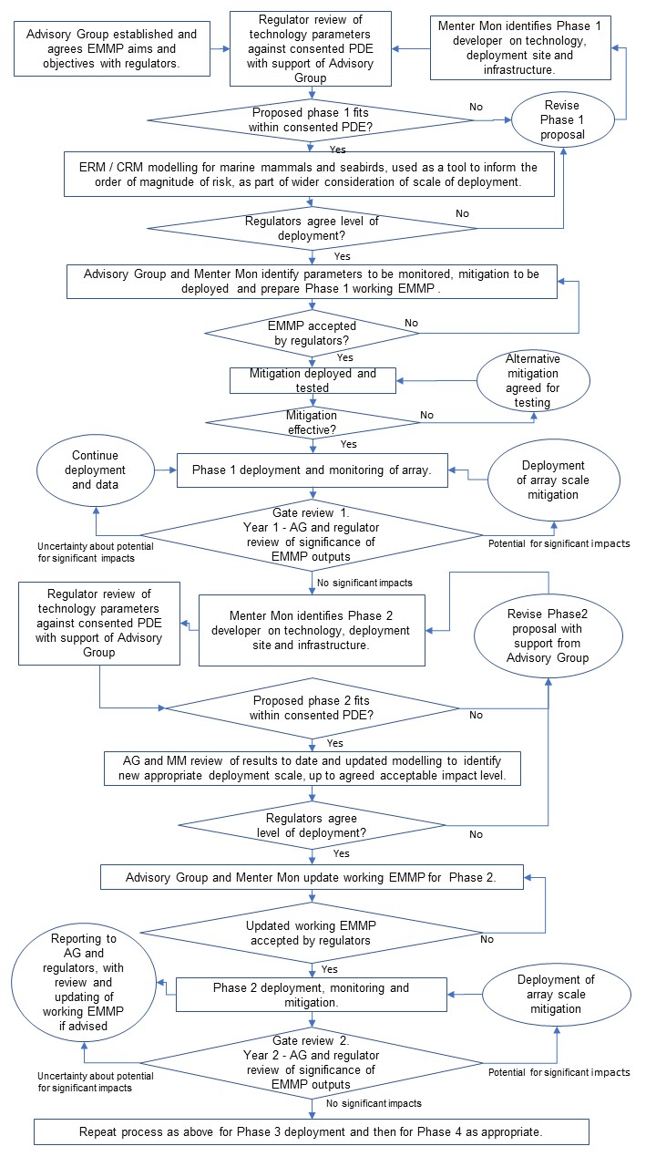
Detailed EMMP
Plate 2-1 Illustration of proposed EMMP process for initial deployment and repowering

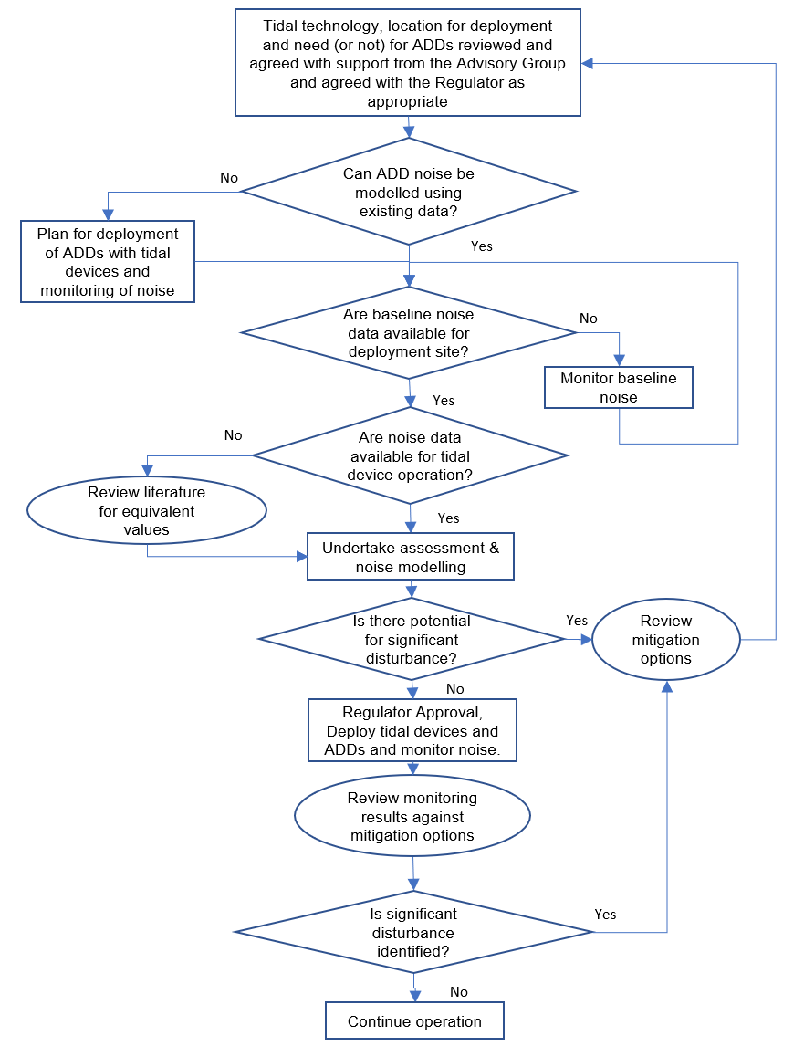
Plate 2-2 Illustration of proposed outline noise modelling and monitoring process within the EMMP

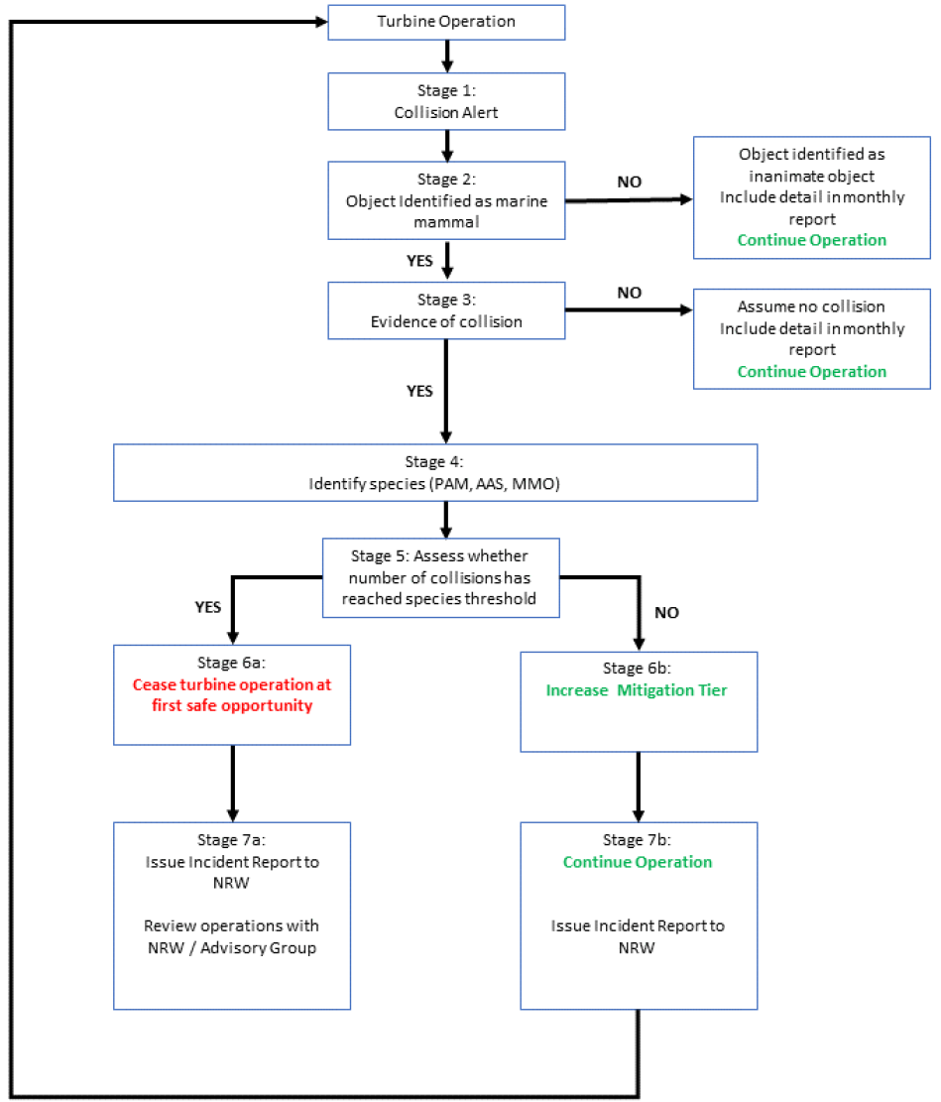
Plate 2-3 Illustration of proposed collision or incident decision framework (from NRW, 2020¹). The figure outlines the decision-making stages when collisions are detected, and subsequent mitigation and reporting requirements

Monitoring and Reporting
- Comprehensive real-time monitoring will be deployed to detect animal movements around the devices and detect or infer any collisions should they occur. Monitoring will be sufficient to differentiate between inanimate objects and marine mammals, but also to discriminate between diving seabirds, dolphin species, porpoise and seals. If it is not possible to determine what has collided with the device, then the ‘worst case scenario’ will be assumed, i.e. that the collision was with the species with the lowest collision limit.
- Prior to any deployment, if possible, it will be clearly demonstrated that there is a robust and reliable means of distinguishing severity of injury, or the precautionary principle would be applied and the ‘worst case scenario’ assumed, i.e. that all collisions are assumed to result in the death of the individual involved.
- All monitoring methods will be demonstrated to be effective in detecting real-time animal movements around the devices prior to device operation. The Advisory Group will support the applicant to ensure that a sufficient period of time or sufficient information to demonstrate that the system is effective is allowed for. The Regulator will have final approval.
- NRW will receive regular, for example, monthly monitoring reports for review, the frequency of which will be agreed in writing. The monitoring reports will include all data of the possible/ confirmed marine mammal or seabird detections. Comprehensive summary reports will also be periodically produced e.g. annually, to allow a review of the efficacy of monitoring.
- In the event of a suspected collision, the collision decision framework process (outlined in Plate 2-3) would be triggered, and NRW would be notified immediately.

Outline Monitoring Indicators
- It is proposed that monitoring indicators and related monitoring questions (See Section 2.5, below) are agreed prior to consent, to allow post consent works to focus on appropriate monitoring methods.
- Indicators for the EMMP will be agreed by an advisory group, however, suggested examples of possible indicators are outlined in Table 2-1 below.
Table 2-1 Outline Monitoring Indicators
Ref. | Indicator | Applicable Monitoring Subject(s) | Metric(s) to be measured
I1 | Change in use of tidal device array deployment area pre and post installation | - Marine Mammals  - Diving Birds  - Mitigation Efficacy | Time spent in device array deployment area.  Activities / behaviour undertaken in device deployment area.  Variations during tidal state and operation / non-operation of deterrent devices.
I2 | Changes in use of the wider MDZ outside the array deployment area | - Marine Mammals  - Diving Birds  - Mitigation Efficacy | Time spent outside of the array deployment area, when compared to array area.  Variations during tidal state and operation / non-operation of deterrent devices.
I3 | Avoidance of individual tidal devices (near field avoidance) | - Marine Mammals  - Diving Birds  - Migratory Fish  - Mitigation Efficacy | Sudden changes in swimming / diving direction around an operational device.  Variations during tidal state and operation / non-operation of deterrent devices.
I4 | Avoidance of array of tidal devices (far field avoidance) | - Marine Mammals  - Diving Birds  - Mitigation Efficacy | Gradual changes to swimming / diving directions in a way correlated to presence of an array of tidal devices.  Variations during tidal state and operation / non-operation of deterrent devices.
I5 | Avoidance of deterrent devices | - Marine Mammals  - Diving Birds  - Mitigation Efficacy | Changes to swimming / diving directions in a way correlated to presence of operational deterrent devices.  Variations in avoidance during deterrent operation compared to non-operation periods, and across a range of tidal states.
I6 | Collision with tidal devices | - Marine mammals  - Diving Birds  - Migratory Fish | Clear direct collision between animal and device, supported by tracking of animal spatially and temporally before and after collision.
I7 | Local population effects | - Diving Birds | Changes to local colony numbers and breeding success over time, potentially indicating changes to mortality.
I8 | Acoustic environment | - Marine mammals  - Mitigation Efficacy | Monitoring of underwater noise environment during operation of devices.  Variation of underwater noise across tidal states, during the operation / non-operation of tidal devices and during the operation / non-operation of acoustic deterrents.
I9 | Validation of ERM and CRM models | - Marine mammals  - Diving Birds | Avoidance behaviour, Nocturnal diving (diving birds), diving behaviour,

Outline Monitoring Questions
- Monitoring questions to be addressed by the EMMP will be reviewed and agreed by the advisory group and the Regulator. Outline monitoring questions that could be derived from monitoring indicators detailed earlier in this document are outlined in Table 2-2 below.
- This process will help the advisory group agree appropriate management measures, and in particular the appropriate scale (MW) of the next phase of deployment for the Project for approval by the Regulator.
Table 2-2 Outline Monitoring Questions
Ref. | Monitoring question | Applicable Monitoring Subject(s) | Purpose of question
Q1 | Is there evidence that receptors use the tidal device array deployment areas in the same of similar ways pre and post deployment? | - Marine Mammals  - Diving birds  - Mitigation efficacy | Evidence of array scale avoidance that may enable revision of modelling of collision and encounter risk and therefore revise collision effect significance.
Q2 | Is there evidence that receptors use the MDZ in the same or similar ways pre and post deployment? | - Marine Mammals  - Diving Birds  - Mitigation Efficacy | Evidence of MDZ scale avoidance that may:  - Enable revision of modelling of collision and encounter risk and therefore revise collision effect significance;  - Q3Allow consideration of potential exclusion.
Q3 | If there evidence of a change to use of the deployment area, is it considered ecologically significant by the advisory group | - Marine Mammals  - Diving Birds | If avoidance is occurring, could it potentially have an adverse effect on the ecology of the monitoring subjects?  For example, might avoidance lead to reduced food availability or increased energy use at a scale that would have an ecological effect?
Q4 | Is there evidence of near field avoidance of devices? | - Marine Mammals  - Diving Birds  - Migratory Fish | Evidence of device scale avoidance that may enable revision of modelling of collision and encounter risk and therefore revise collision effect significance.
Q5 | Is there evidence of collision? | - Marine Mammals  - Diving Birds  - Migratory Fish | Evidence of collision would require corrective measures to be applied, for example approaches to improve avoidance such as use of acoustic or visual deterrents.  Revision to modelling of encounter and collision risk may be required.
Q6 | Is there evidence that tidal state may influence avoidance behaviours for devices and for acoustic deterrents? | - Marine Mammals  - Diving Birds  - Migratory Fish | Revision to modelling of encounter and collision risk may be required.  Inform decisions regarding use of acoustic deterrents.
Q7 | Is there evidence that deterrents work? | - Marine Mammals  - Diving Birds  - Mitigation Efficacy | Inform decisions regarding their use as mitigation.
Q8 | Is the underwater noise environment during operation of devices and acoustic deterrents as predicted in modelling? | - Marine Mammals  - Mitigation Efficacy | Inform assessment of behaviour of animals and responses to operational tidal devices and acoustic deterrents.  Review predicted efficacy of acoustic devices.
Q9 | Can the next phase of deployment take place? | - Marine Mammals  - Diving Birds  - Migratory Fish  - Mitigation Efficacy | Gate check by the advisory group for the scale of deployment of the next phase of the Project.
Q10 | Does the monitoring and mitigation plan need to be reviewed and updated? | - Marine Mammals  - Diving Birds  - Migratory Fish  - Mitigation Efficacy | Are the monitoring methods still appropriate or can they be removed or revised?

EMMP Roles and Responsibilities
- This section of the outline EMMP details roles, responsibilities and lines of communication during phased deployment of the Project.

Ownership of the EMMP
- The Applicant will have responsibility for ensuring the EMMP is implemented.
- The Applicant may appoint an appropriate secretariat to manage the EMMP.
- The environment lead within the Applicant’s ‘Project Team’ will manage, revise and report on the outputs of the EMMP to Regulators.

Role of the regulators in the Advisory group
- Two consenting bodies are involved in the consent of the Project, Natural Resources Wales (NRW) Licensing and Welsh Government through the Planning Inspectorate (PINS Wales).
- It is anticipated that enforcement of the EMMP and other marine management measures will be through conditions placed on the Marine Licence, with NRW Licensing as the regulator. PINS Wales would play no further role in the EMMP.
- NRW Licensing will have the ability to curtail operation of the project in response to adverse environmental impacts reported to it through the EMMP.
- Regulators have played an active role within Advisory Groups for other equivalent projects such as the MeyGen tidal array (Terms of Reference for MeyGen are provided in Appendix 2), SeaGen Strangford Lough, and several offshore windfarms, with associated benefits for communication and speed of response.
- For the Project,NRW Licensing will consider relevant outputs/reports from EMMP activities, as submitted by the applicant. providing responses and advice after deliberation..

Appointment and role of the Advisory Group
- The Advisory Group will have an Independent Chair, appointed by the Applicant. The Independent Chair will be a person with experience of environmental consenting and monitoring works, with a level of technical expertise and an understanding of tidal energy.
- The role of the Advisory Group, under the stewardship of its Independent Chair, will be to advise the Applicant regarding the implementation of the EMMP.
- The Regulators engagement with the Advisory Group will be without prejudice to their regulatory role, and they will be under no obligation to accept or act upon advice.
- The Applicant recognises that an effective EMMP will be critical to the success of the Project. For this reason, it is proposed that an advisory group for the Project is established, consisting of core organisations relevant to help support the applicant with the implementation of the EMMP. The applicant is responsible for the delivery of the EMMP.
- The Advisory Group will provide oversight of the EMMP, providing a forum for the agreement of monitoring works, provision of technical information, and the development of practical recommendations to both the Applicant and the Regulator. Final approval on deployment, monitoring and mitigation will be required from the regulator
- The Morlais advisory group will be supported by a secretariat, appointed by the Applicant, which will undertake the day to day management of the EMMP.
- Membership of the advisory group in outline is anticipated as:
Independent Chair – independent advisor to the Applicant and arbiter of discussions;
The Applicant;
Deploying tenant(s) may be included by invitation on an ad hoc basis;
Natural Resources Wales Advisory – as technical experts (marine mammals, diving birds and migratory fish)
Marine mammal advisors – academic expertise;
Ornithology advisors – academic expertise;
Royal Society for the Protection of Birds (RSPB) – advocate for diving bird interests and as manager of South Stack Reserve, the location of seabird colonies to be monitored.
Environmental Clerk of Works (ECoW) for marine works– appointed by the Applicant, with responsibility for overseeing implementation of EMMP and other management plans post consent.

Governance
- The appointment of an Independent Chair of the Advisory Group will be undertaken by the Applicant.
- Decisions made under the EMMP will require agreement of the Regulator before they can be implemented.
- The Regulators will have control of the scale of deployment and mitigation required for any phase of the Project. This ‘gate keeping’ role will enable them to ensure that that deployment scales and mitigation are appropriate to ensuring that no adverse effect on integrity occurs, while, taking into account the provision of any detailed EMMP for that deployment and previous deployments.

Meetings and reporting
- An outline schedule for the initial stages of development and implementation of the EMMP is provided in Table 5–1.
- It is proposed that technical reports detailing the outcomes of monitoring will be reported for review on a quarterly basis, closely followed by quarterly ‘meetings’ (face to face or via tele / video conference) of the Advisory Group to discuss monitoring outputs in light of agreed EMMP aims, objectives and monitoring questions.
- Between quarterly reports, short briefing notes will be sent to Advisory Group members with a summary of monitoring outputs in the preceding month.
- If a significant emergency event or incident occurs, then an ad hoc ‘meeting’ of the Advisory Group will be held as soon as possible.
- Measures and procedures relating to Emergency Response are detailed below.

Emergency Response
- Agreement of an appropriate protocol for the management of ‘incidents’ identified through monitoring will be agreed by the Advisory Group with final approval by the Regulator.
- It is anticipated that an incident management protocol would follow a similar approach to that used for oil spill response or other major environmental incident (for example flood risk) management. Examples are available from previous tidal deployments such as SeaGen, Strangford Lough, as well as other industrial sectors and would be reviewed for appropriateness and potential lessons learned.
- A communications or incident tree for rapid transmission of important information will be agreed by the Advisory Group. This will involve identification of key contacts within the organisations represented within the Advisory Group.

Outline Approach to Mitigation and Monitoring Methods

Mitigation
- Through the development of the EMMP the applicant will demonstrate mitigation options which can achieve demonstrable reduction in marine mammal collisions with operational turbines.
- In accordance with NRW (2020)¹, mitigation options would be considered such that mitigation can be adapted in response to any increasing risk of causing adverse effect, this would be in line with the collision decision framework (Plate 2-3). Through the detailed EMMP the applicant will clearly set out how the response to any single marine mammal collision (assumed or actual) will be to minimise the risk of further collision events by setting out the further options that would be available to achieve this. This will include detailed description of the tiers of mitigation ranging from no mitigation; active deterrence; device modification; to cease operation of tidal device. These tiers of mitigation would be ready to be deployed in response to the pre-agreed species trigger levels being reached.
- Through the EMMP the applicant makes a commitment that if mitigation is not effective in preventing collisions, a failsafe will be included to ultimately prevent an adverse effect from occurring. Such a failsafe is likely to be the cessation of operations of the tidal device.
- Mitigation will take several forms during implementation of the EMMP, allowing potential significant impacts on marine mammals and diving birds to be managed. The anticipated routes to mitigation within the EMMP are summarised below.

Mitigation through Phased Deployment
- Initial stage of deployment will be limited at a level where no significant impacts on sensitive receptors are predicted.

Mitigation as a Result of Tidal Array Characteristics
- ‘Natural’ or ‘passive’ deterrence and displacement of species from operational turbines as a result of animals’ perception of presence of the array through acoustic and other senses, and their subsequent avoidance of tidal devices or the tidal array deployment area, without significant disturbance effects.

Mitigation through Corrective Measures – Active Deterrence
- Potential use of acoustic deterrent devices (ADD) or visual deterrents to deter animals from any arrays deployed, if monitoring indicates that there may be an unacceptable level of collision risk at levels of deployment above the agreed ‘no significant impact’ level of deployment.

Mitigation through Corrective Measures – Moderation of Operation
- The slowing or other modification of the operation of installed tidal devices to reduce predicted risk identified of collision.

Mitigation through Corrective Measures – Stopping or Removal of Devices
- The temporary or permanent stopping or removal of deployed tidal devices.

Monitoring

Monitoring and mitigation methods
- The use of appropriate and effective monitoring and mitigation methods based on review of available research and wider expertise will be recommended by the AG to the Applicant. Approval of monitoring and mitigation will be required from the Regulator prior to deployment.
- The Advisory Group will identify and agree appropriate monitoring and mitigation methods prior to deployment with final approval by the Regulator. However, suggested methods are detailed below in outline at this stage, but subject to revision as methods and technologies improve.
- Monitoring methods considered will be appropriate to monitoring of species behaviour and therefore for monitoring efficacy of mitigation. For example , underwater noise monitoring will be based on the latest techniques, taking into account array layout, ambient noise levels and predicted operational turbine and ADD noise levels. If required, underwater noise mitigation measures that could be considered to reduce the risk of significant disturbance from underwater noise could include: a limit on the number of ‘noisy devices’, device modification, noise abatement, and options to limit the use of ADDs to minimise unnecessary disturbance while ensuring that they are still able to achieve mitigation of marine mammal collisions.

- In order to address the monitoring questions identified for the Project, suitable monitoring methods will be agreed with regulators, and monitoring equipment suitable for the type of data collection and the characteristics of the MDZ will be identified.
- A short review of potential monitoring methods for relevant indicators is outlined in Table 4-1 below. Mitigation methods are also considered. The methods anticipated as being most appropriate to Morlais based on current understanding, are highlighted in blue summarised in Table 4-1, however, all the methods summarised and any new and developing technologies will be considered and reviewed during development of the EMMP.
- The efficacy of monitoring and mitigation methods will be demonstrated prior to operation of the turbines.
- All of the monitoring and mitigation methods proposed for consideration are described in monitoring literature, and their use is considered to realistic, effective, sufficient and deliverable, with their use depending upon the monitoring question to which they are addressed

Table 4-1 Review of Potential Monitoring and Mitigation Methods
Monitoring and mitigation methods | Receptor group targeted | Monitoring approach and data type | Uses for monitoring data | Outline EMMP indicator(s) | Rationale for consideration of method for EMMP | Related references to Tables 2-1 and 2-2
Passive acoustic monitoring (PAM) | Marine mammals | Approach: Seabed mounted, moored or floating arrays of hydrophones.  Data type:  Sound files with directional and sound level components. Interpretation by human operators and / or acoustic modelling, including spatial location of sound sources. | Deployed in array around device array and in wider study area.  Tracking of movement of animals and behaviour in real time, or through review of stored data.  Presence / absence of animals within an array deployment area over time.  Movement of animals through and within an area over time.  Position of animals within an area over time  Tracking of avoidance behaviour or other interaction.  Trigger mechanism for mitigation measures.  Efficacy of mitigation measures | Change in use of tidal device deployment area pre and post installation.  Avoidance of tidal devices or of deterrent devices. | PAM has been deployed at a number of marine renewable energy sites to date.  PAM has shown its effectiveness in alerting monitoring programmes to the presence of cetaceans in a monitored area.  PAM has the potential for automation and reduced costs.  Local expertise in the use of PAM exists within SEACAMS.  PAM has been deployed within the MDZ as part of SEACAMS | I1  I2  I4  I5  I8  Q1  Q2  Q6  Q7  Q8
Active sonar | Marine Mammals  Seabirds  Migratory Fish | Approach:  Seabed mounted, device mounted or moored directional sonar.  Active sonar activated by PAM.  Data can be stored for later analysis or analysed live.  Data type:  Visual files, which can be interpreted by a human operator, or by mathematical algorithm. | Used from seabed mounted platforms or device mounted.  Tracking of movement of animals and behaviour in real time, or through review of stored data.  Tracking of avoidance.  Trigger mechanism for mitigation measures such as ADD.  Efficacy of mitigation measures | Change in use of tidal device deployment area pre and post installation  Avoidance of tidal devices or of deterrent devices.  Collision with tidal devices | Active sonar has been deployed at a number of tidal energy sites to date.  The ability of active sonar to track marine mammals, and potentially seabirds, swimming or diving close to tidal devices has been demonstrated both at operational sites and experimentally.  For seabirds it seems unlikely that such methods would be able to determine species, so monitoring may have to assume any collisions are attributed to the target species.  Potential for tracking migratory fish will be explored. | I3  I6  Q1  Q4  Q5  Q6
Surface infra-red / visual spectrum camera | Marine mammals (surface) and Diving Birds (surface) | Approach:  Surface mounted moored platform or device.  Data type:  Visual files for interpretation by human operator | - Used from a surface platform, potentially  - Presence / absence on surface only.  - Tracking night and day.  - Efficacy of mitigation measures | Change in use of tidal device deployment area pre and post installation | Limited to surface use.  Clarity is required regarding efficacy of the technology over prolonged periods and as to the nature of the platforms required | I1  I2  I4  I5  Q1  Q2
Underwater camera | Marine Mammals, Diving Birds, Migratory Fish | Approach:  Seabed, device or platform mounted.  Data type:  Visual files for interpretation by human operator. | - Tracking in day and during good visibility periods.  - Tracking of movement of animals and behaviour in real time, or through review of stored data.  - Seabed based monitoring platform viewing one device.  - Device mounted monitoring viewing one device. | Change in use of tidal device deployment area pre and post installation  Avoidance of tidal devices or of deterrent devices  Collision with tidal devices | Underwater camera offers potential to monitor interaction between tidal devices and species in situ. However, the technology is dependent upon good visibility. | I3  I6  Q4  Q5  Q6
Vantage point (VP) surveys | Marine mammals (surface) and diving birds (surface) | Approach:  Human observation from nearby cliffs.  Data:  Manual record of behaviour | - Presence and absence of animals in real time.  - Numbers and behaviour of animals at study area.  - Proximity to shore and elevation of VP important. Limited to surface information.  - Efficacy of mitigation measures | Change in use of tidal device deployment area pre and post installation | VP surveys are limited to surface use only and required good visibility and so potential to record avoidance behaviour is limited.  Use of VP would require the array location to be relatively close to shore to allow observation. Their use at distances more than 1km may be limited. | I1  I2  I4  Q1  Q2  Q6  Q7
Colony counts and estimation of breeding productivity | Diving Birds | Approach:  Human observation (or possibly long distance photography).  Monitoring would be undertaken pre- and post-deployment to enable detection of change associated with deployment.  Data:  Manual record of numbers / breeding productivity (possibly including photographic data) | - Numbers of animals active within colonies of interest.  - Numbers of chicks reared per pair  - Colony health and viability | Local population effects | Robust and basic measure of colony health over time.  It is likely that relatively long-term monitoring (e.g. over several years) would be required for detection of possible effects on numbers of breeding birds attending the colony.  Large-scale effects of deployment could potentially be detected through declines in breeding productivity (i.e. as a result of high mortality of breeding adults during the breeding period).  Discussions with RSPB have suggested such colony monitoring is likely to be possible. | I7
Tracking of movement and diving behaviour. Global Positioning System (GPS) tags for determining movements and foraging areas and Time Depth Recorder (TDR) loggers for recording diving behaviours | Diving Birds | Approach:  Annual capture and tagging of a portion of the breeding adult guillemots and razorbills at the South Stack and Penlas colonies. Discussions with RSPB have indicated that it may be possible to catch and equip 15 individuals of each species per year.  To be undertaken per- and post-deployment to enable detection of changes associated with deployment.  Data would include time referenced data indicating main foraging areas.  Also, data on diving activity (including frequency and duration) and dive depths, speed and acceleration, and differences between daytime and nightime periods on these parameters.  May require roped access skills given nature of the colony. | - Tracking of movement of animals and behaviour to determine the effects of deployment on these (e.g. in terms of displacement from foraging areas or avoidance of areas occupied by the devices)..  - Refinement and validation of several key input parameters for the ERM / CRM | Change in use of tidal device deployment area pre and post installation.  Refinement of collision estimates to indicate extent of precaution (or not) within existing estimates.  Local population effects | Method used for a number of seabird species in literature, with other UK studies having used these methods on both guillemot and razorbill (including remote download for both GPS and TDR data, avoiding need to recapture birds to retrieve loggers). Similar tracking work is already being undertaken on guillemots at nearby breeding colonies in North Wales  Opportunity to track locations of feeding, and other relevant input parameters for collision estimation such as dive depths and durations. | I1  I2  I3  I4  Q1  Q2  Q7
Acoustic Deterrent Devices | Marine mammals  Diving birds | Approach:  Deployment of array around deployed devices. | Proposed mitigation measure for use within EMMP to mitigate collision risk for marine mammals by deterring mammals from proximity to active tidal devices. | Change in use of tidal device deployment area pre and post installation.  Avoidance of tidal devices or of deterrent devices. | Currently used to deter marine mammals from noisy operations around offshore windfarm construction. | I5  Q6
Visual deterrents | Diving birds  Marine Mammals  Migratory fish | Approach:  Deployment of physical deterrent (coloured ribbons), or submerged strobe lights | Proposed mitigation measure for use within EMMP to mitigate collision risk for diving birds by deterring diving birds from proximity to active tidal devices. | Avoidance of tidal devices or of deterrent devices. | Opportunity to investigate possible used of methods such as strobes and physical deterrents to deter potential receptors. | I5  Q6
Underwater noise measurements and monitoring of operational turbines and activated ADDs | Marine Mammals | Approach:  Deployment of hydrophones | To ensure noise levels do not exceed predicted modelled levels that could result in significant disturbance. | Significant disturbance as a result of underwater noise from operational turbines and activated ADDs. | Hydrophones have been used at a number of sites to monitor underwater noise levels from various activities.  The type / system of hydrophones will be based on the latest information based on requirements in relation to predicted noise ranges and areas. | I8  Q8

- Not all the methods outlined in Table 4-1 will be used in the EMMP, and new methods may become apparent. Decisions regarding appropriate methods will be made by the Applicant in consultation with the advisory group. Factors affecting those decisions may include:
Effectiveness of the methods and equipment in collecting suitable data to address the monitoring questions;
Suitability of the monitoring method to the MDZ, and to specific deployment location within the MDZ;
Cost of equipment and its management, including data processing and reporting needs;
Power and data recovery requirements;
Robustness and reliability of monitoring equipment;
Applicability of data collected to addressing monitoring questions; and
Accessibility of equipment.
- This outline EMMP will be considered alongside a detailed review of monitoring and mitigation for marine mammals, which details some of the methods and techniques currently being considered for monitoring of, and mitigation of impacts on, marine mammals. It is proposed that a similar review will also be undertaken of options for monitoring of, and mitigation of impacts upon, diving seabirds.

Monitoring of mitigation
- Several of the monitoring questions proposed in this outline EMMP (See Table 2-2) and potential monitoring methods identified to address those questions (See Table 4-1) are appropriate to monitoring the efficacy of mitigation measures, if they are applied.

Outline schedule of EMMP Tasks
- Table 5-1 below, outlines an indicative schedule for post consent tasks under the EMMP from consent to completion of first phase deployment.
- Throughout the process detailed in Table 5-1 from item 10 onwards, the Advisory Group will undertake detailed review of monitoring data on a quarterly basis or as required by trigger or emergency events.
Table 5-1 EMMP Outline Post Consent Schedule of Tasks
Item No. | Project Stage | Task | Task component | Organisational responsibility | Time period
1 | Pre- or within 6 months after consent | Agreement of detailed EMMP approach, based on outline EMMP | Terms of reference | Menter Môn (MM)  Regulators | Ongoing to June 2021
2 | Pre- or within 6 months after consent | Establish Morlais EMMP Advisory Group | Appoint Independent Chair and group members  Appoint technical advisors | MM | Ongoing to June 2021
3 | Pre- or within 6 months after consent | Procurement of EMMP support | Appointment of secretariat  Appointment of technical contractors | MM  Advisory Group | Ongoing to June 2021
4 | Pre- or within 6 months after consent | Agree EMMP framework | Aims  Objectives  Monitoring questions  Methods | MM  Advisory Group | Ongoing to June 2021
5 | Post consent & pre-construction | Identify phase 1 Technology and no impact installed capacity.  Incorporate into EMMP | Collision and encounter modelling | Advisory Group  MM  Tenant  Regulatory approval | August 2021 to October 2021
6 | Post consent & pre-construction | Identify phase 1 array location.  Incorporate into EMMP | Review of site data | MM  Tenant  Regulatory approval | August 2021 to October 2021
7 | Post consent & pre-construction | Procurement of monitoring services | Equipment  Installation Contractors  Monitoring contractors | MM  Tenant | Nov 2021 to December 2022
8 | Offshore infrastructure construction & pre-array deployment | Installation of offshore project infrastructure.  Incorporate into EMMP | Export cables  Cable protection  Installation of monitoring equipment | MM  Advisory Group  Regulatory approval | January 2023 to December 2023
9 | Offshore infrastructure construction & pre-array deployment | Implement EMMP | Commencement of monitoring works | MM  Advisory Group  Regulatory approval | Commence April 2023 - ongoing
10 | Phase 1 Deployment | Installation and commissioning of first phase array  Monitor for emergency trigger events.  Implement EMMP | Inter-array cables  Tidal devices | Tenant  Regulatory approval | January 2024 to December 2024
11 | Phase 1 Deployment | Monitor for emergency trigger events.  Implement EMMP. | Gate review of monitoring works and advice to MM and Regulator | Advisory Group  Regulatory approval | December 2025 – March 2026
12 | Phase 2 Deployment | Installation and commissioning of second phase array.  Implement EMMP. | Inter-array cables  Tidal devices  Installation of second phase monitoring equipment | Tenant  MM  Advisory Group  Regulatory approval | March 2026 onwards
13 | Phase 2 Deployment | Implement EMMP. | Gate review of monitoring works and advice to MM and Regulator | Advisory Group  Regulatory approval | 12 monthly after commencement of installation
14 | Phase 3 Deployment | Repeat as for second phase
15 | Phase 4 Deployment. | Repeat as for third phase

Summary of Outline Approach
- The outline and detailed EMMP will be the responsibility of the Applicant, under the guidance of an independently chaired Advisory Group.
- The Regulators / Competent Authorities will have final review and make final decision regarding the scale of deployment and type and use of mitigation.
- The EMMP will consider potential effects of operational tidal devices (collision risk and underwater noise), deployed in a phased approach by the Project, on seabirds and marine mammals using the MDZ.
- Initial deployment of the Project will be at a level indicated by environmental assessment to have no significant environmental impact.
- The EMMP will operate within a framework of agreed objectives and structured monitoring questions.
- Monitoring works will begin before deployment to allow before and after comparison.

Marine Mammals
- For marine mammals a number of methods will be used to monitor the potential collision risk and any significant disturbance as a result of underwater noise:
Use of the array area and approaches to the array area by marine mammals;
Behaviour of marine mammals adjacent to operational device(s) in the array, possibly including:
Proximity of approach to device;
Passage / non-passage through devices;
Evidence of collision; and
Avoidance behaviour.
- The absence of evidence of collision and / or evidence of avoidance of the array or of devices within the array would be expected to lead to agreement for deployment of a further phase, with no potential for any significant disturbance from underwater noise.
- Evidence of collision, or non-avoidance would be expected to lead to consideration of use of mitigation such as ADD, and consideration of further monitoring before further deployment.
- The advisory group would agree on monitoring appropriate to following stages of deployment.

Diving Seabirds
- For diving seabirds, a number of methods will be used to monitor:
Spatial use the array area and wider MDZ by diving birds;
Nature of diving in the array area, for example diving depth and duration;
Relevant seabird colony surveillance, including colony counts.
- Non-use of the array area by species being monitored during the first phase of deployment would be expected to lead to agreement that any pathway for effect on those species through collision did not exist.
- Where diving birds use the array location, diving depth and duration data would allow refinement of collision models, while colony surveillance will allow for ongoing review of numbers during deployment and refinement of PVA, to inform advisory group review of potential effects of further deployment.

Migratory Fish
- When active sonar and video data are analysed for marine mammal and seabird behaviour, the same footage will also be reviewed and analysed to identify if they also contain potential information on behaviour of migratory fish in the visible area around the TEC’s. The objectives of this analysis will be to:
(a) detect any migratory fish in proximity of the TEC devices;
(b) describe any observed avoidance behaviour;
(c) identify any interactions between turbine blades and migratory fish, and
(d) where possible determine the consequence of any collisions, should any occur.
- Analysis of the active sonar and video monitoring data for migratory fish, will be in addition to the monitoring of those same data for marine mammal and bird activity. The trigger for analysis will be the agreed trigger points for marine mammals or seabirds, as discussed in Section 1.3.8.
- The Applicant commits to make all data collected during monitoring under the EMMP available for use by researchers with the aim of supporting develop this broader understanding of interactions between TECs and migratory fish.

References
Furness, R.W., Wade, H.M., Robbins, A.M.C., Masden, E.A., 2012. Assessing the sensitivity of seabird populations to adverse effects from tidal stream turbines and wave energy devices. ICES Journal of Marine Science 69, 1466–1479. https://doi.org/10.1093/icesjms/fss131.
Joint Nature Conservation Committee (JNCC), Department of Agriculture, Environment and Rural Affairs (DAERA) and Natural England, 2020. Guidance for assessing the significance of noise disturbance against Conservation Objectives of harbour porpoise SACs (England, Wales & Northern Ireland). June 2020.
Marine Space, 2020. Additional Information to Support Morlais Habitats Regulations Assessment (migratory fish).
Natural Resources Wales (NRW), 2020¹. Advice on adaptive management of the risk of collision impacts on protected marine mammal species in Welsh waters from the Morlais Project. Dated 15/10/2020.
NRW,2020². Using adaptive management for marine developments. Guidance for marine developers. Current on line advice dated 01/11/20. https://naturalresources.wales/guidance-and-advice/business-sectors/marine/using-adaptive-management-for-marine-developments/?lang=en
Savidge, G, Ainsworth, D., Bearhop, S., Christen, N., Elsaesser, B., Fortune, F., Inger, R., Kennedy, R., McRobert, A., Plummer, K. E., Pritchard, D. W., Sparling, C. E. and Whittaker, T. J. T. 2014. Strangford Lough and the SeaGen tidal turbine. In Marine Renewables and Society. Ed. by M.A. Shields. Springer, Dordrecht.

Appendix 1. Consent condition examples

MeyGen - Tidal stream project - example consent conditions
The MeyGen tidal stream array project is subject to the following two relevant consent conditions.

Environmental Monitoring Condition
“The Company must, no later than 3 months prior to the Commencement of the Development, submit a Project Environmental Monitoring Programme (“PEMP”), in writing, for the approval of the Scottish Ministers, in consultation with SNH and any other ecological, or such other advisors as required at the discretion of the Scottish Ministers. The PEMP must set out the measures of monitoring the environmental impacts of all stages of the Development, including the pre-construction, construction, and operational stages. The PEMP must be regularly reviewed by the Scottish Ministers, at timescales to be determined by the Scottish Ministers, in consultation with SNH and the Advisory Group referred to in condition 13 of this consent. Following such review the Scottish Ministers may, in consultation with SNH and the Advisory Group, require the Company to amend the PEMP and submit such an amended Programme to them, in writing, for their approval, in consultation with SNH and any other ecological, or such other advisors as required at the discretion of the Scottish Ministers.” ……

Advisory Group condition
.”The Scottish Ministers must, within 6 months of the date of the granting of the Section 36 consent, establish an Advisory Group to provide advice upon, and oversee, the EMP and the PEMP. Membership, terms of reference and functions of the Advisory Group are to be agreed by the Scottish Ministers in consultation with any such advisors at the discretion of the Scottish Ministers.”

Beatrice offshore wind farm – example consent condition

Advisory Group Condition
“The Company must participate in any Moray Firth Regional Advisory Group (“MFRAG”) established by the Scottish Ministers for the purpose of advising the Scottish Ministers on research, monitoring and mitigation programmes for, but not limited to, ornithology, diadromous fish, marine mammals and commercial fish. Should a SSMEG be established (refer to condition 29), the responsibilities and obligations being delivered by the MFRAG will be subsumed by the SSMEG at a timescale to be determined by the Scottish Ministers.”
“The Company must participate in any Scottish Strategic Marine Environment Group (“SSMEG”) established by the Scottish Ministers for the purposes of advising the Scottish Ministers on research, monitoring and mitigation programmes for, but not limited to, ornithology, diadromous fish, marine mammals and commercial fish.”

Appendix 2 Advisory Group Terms of Reference example
Outline terms of reference for the Advisory Group for The Project are proposed in Section 2 of this outline EMMP. A further example of terms of reference for MeyGen, as consented tidal array is also provided below.
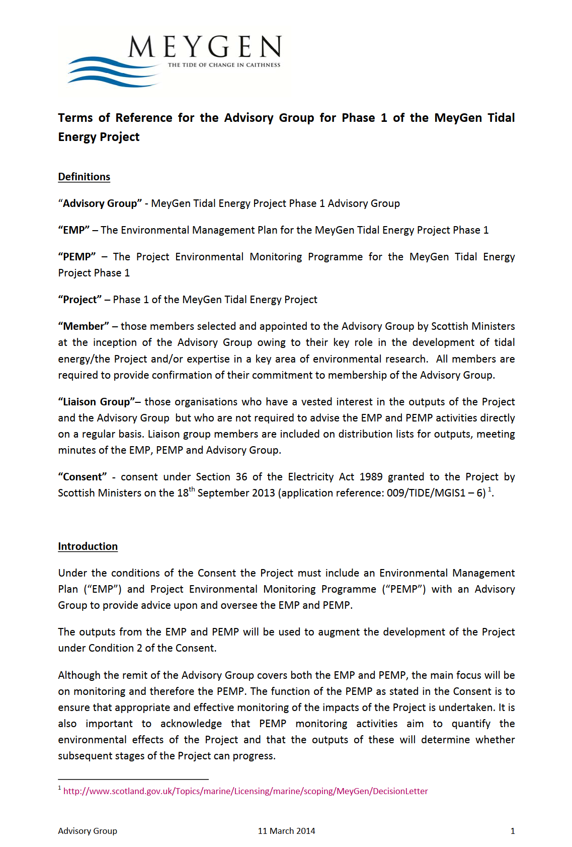
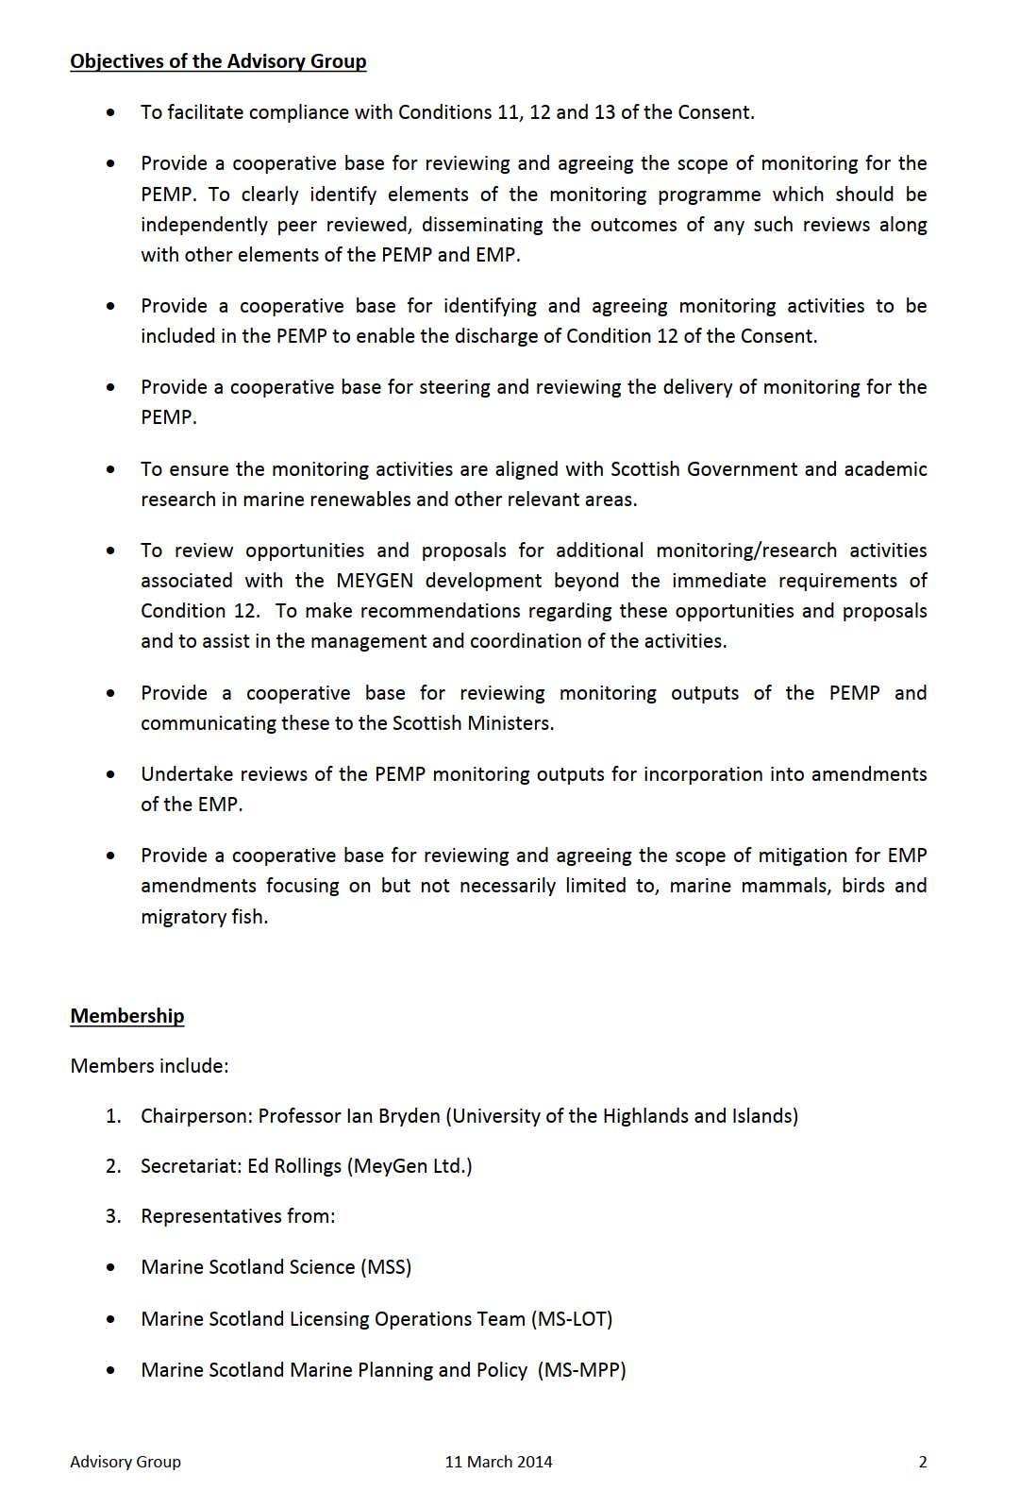

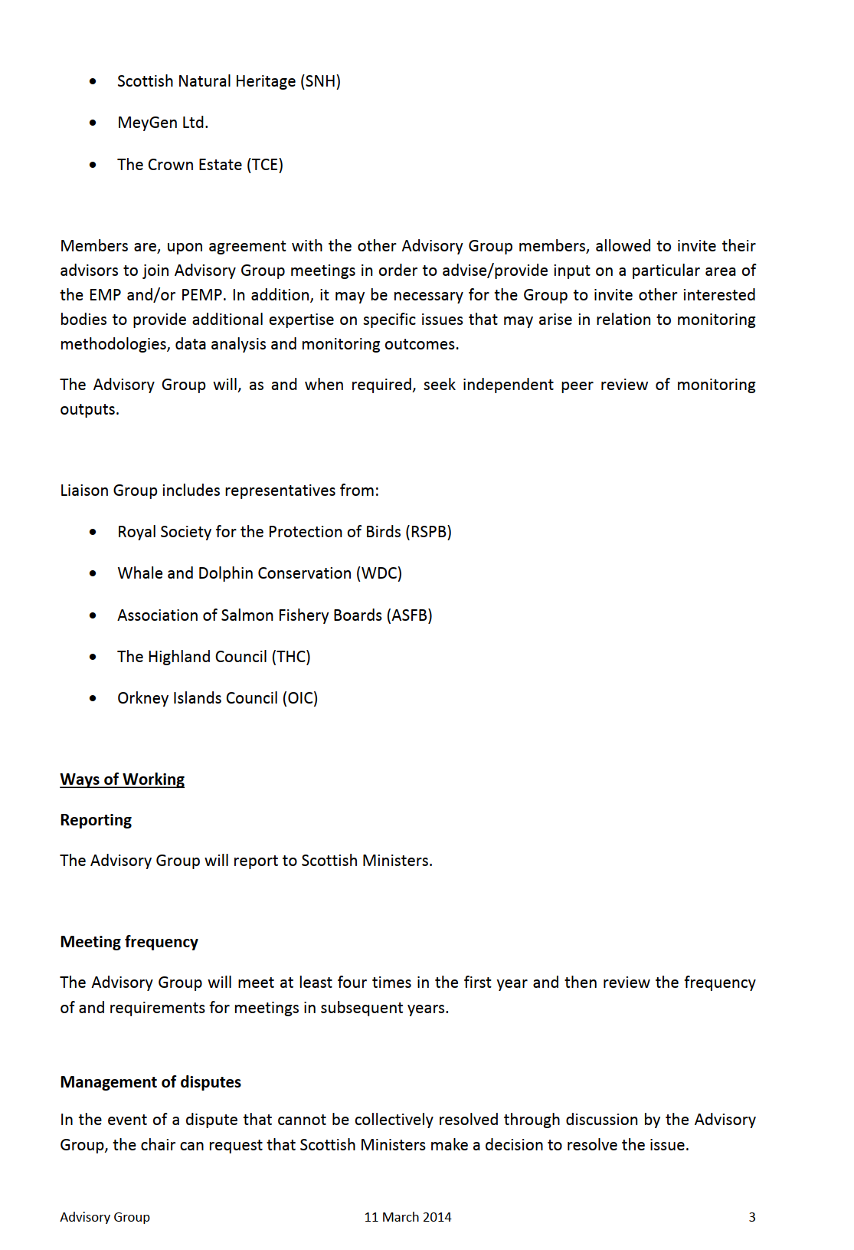
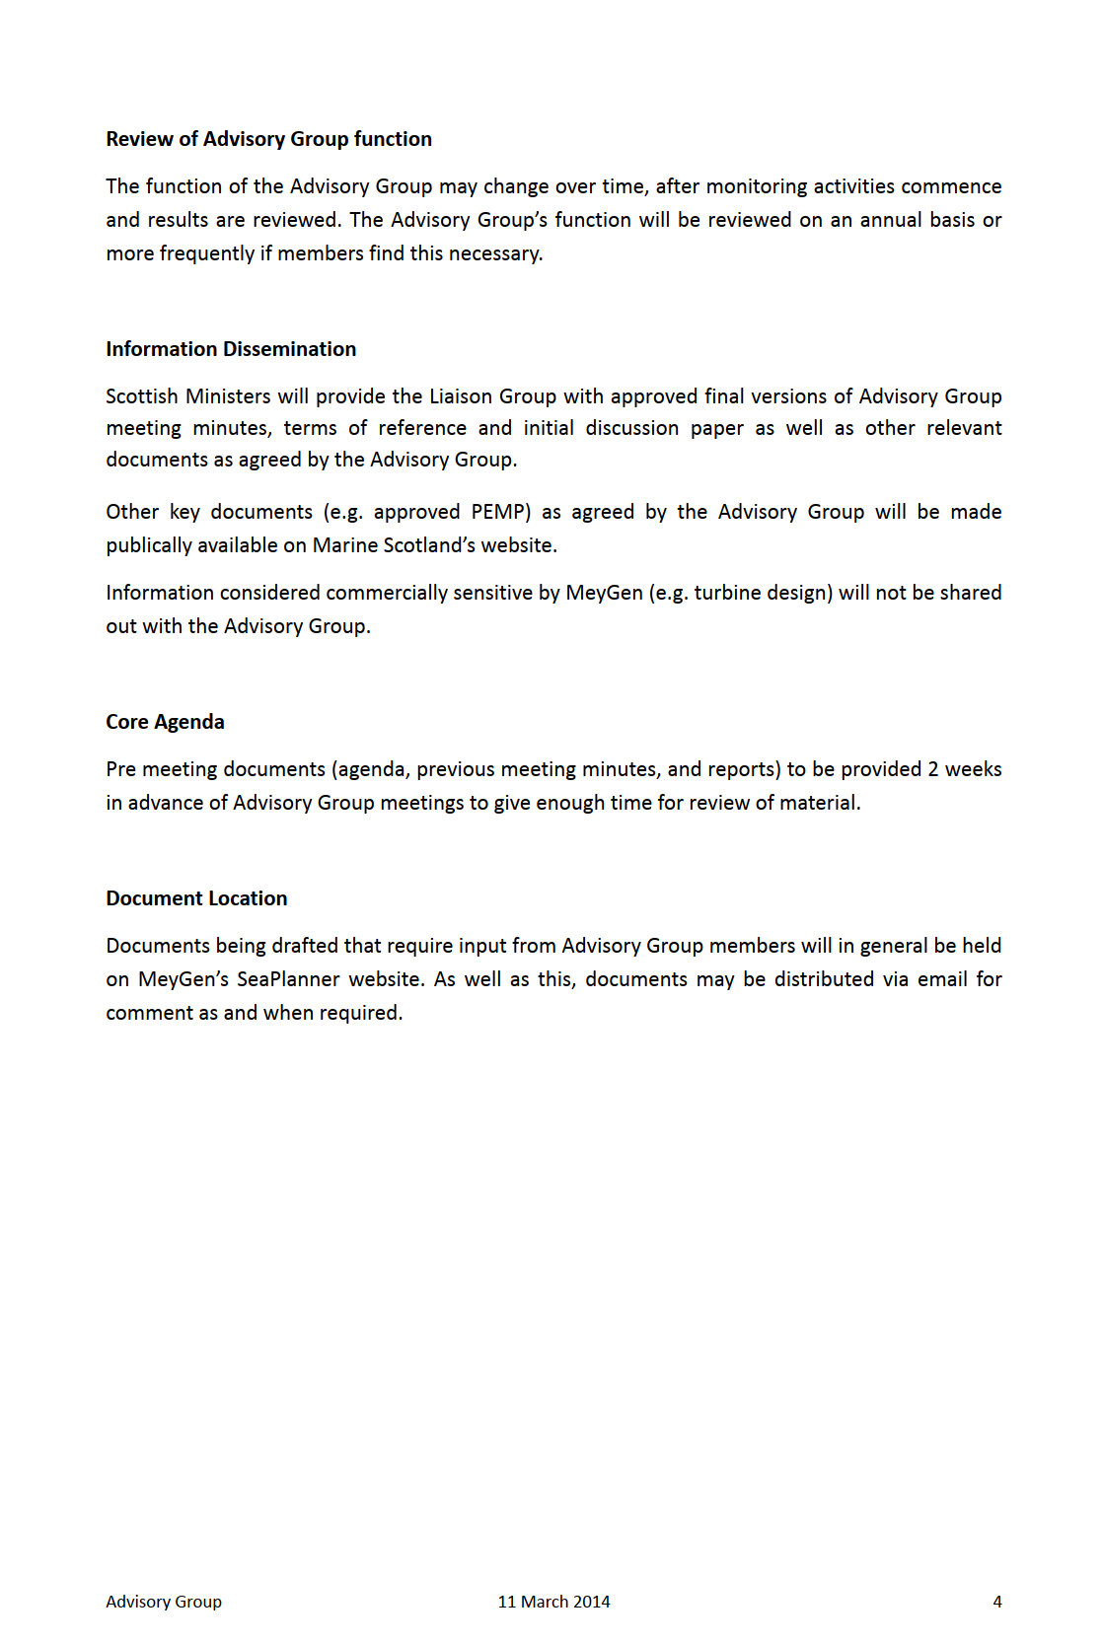

Appendix 3. Phased deployment – example
Table 9-1 below outlines an indicative deployment scenario for the Project. This example is for illustrative purposes only and does not form the basis for management or for any consent conditions.

Table 9-1 Indicative Phased Deployment Scenario and Timeframe
Project stage | Nature of activity | Indicative timeframe
Post consent and pre-deployment | - Installation of marine infrastructure  - Installation of monitoring equipment  - Baseline monitoring | January 2023 to December 2023
Phase 1 deployment and monitoring | - Small demonstration array.  - C14MW installed capacity to date | January 2024 to March 2026
 | - Gate review | March 2026
Phase 2 deployment and monitoring | - Early commercial scale  - 40MW installed capacity to date (c14MW of first array plus 26MW of additional array, or addition to first array) | March 2026 to March 2028
 | - Gate review | March 2028.
Phase 3 deployment and monitoring | - Commercial array  - 100MW capacity to date (40MW of Phase 1 and 2 plus an additional 60MW) | March 2028 to March 2032
 | - Gate review | March 2032
Phase 4 deployment and monitoring | Commercial arrays to full installed capacity of 240MW | March 2032 to March 2036
 | Project monitoring final report | March 2038

Appendix 4 – Proposed marine licence condition

It is accepted by the Applicant that the terms of any marine licence to be granted in respect of the Morlais Demonstration Zone will be a matter for Natural Resources Wales in its capacity as marine licence regulator. However, the Applicant would be content both to propose to the regulator, and to accept to be imposed on the marine licence as follows:

"Condition 36 - No tidal device(s) may be constructed or repowered until a Detailed Environmental Management and Monitoring Plan (DEMMP) the intention of which is to prevent injury marine mammals and diving birds in the operation of those devices, and which is in accordance with the requirements of the Outline Environmental Management and Monitoring Plan (OEMMP), and which incorporates the following (insofar as relevant to that activity or phase of activity) has been submitted to and approved in writing by NRW:

(i) details of proposed pre-operational surveys including a programme and methodology, baseline report format and content;
(ii) details of the model approved by the advisory group established under the OEMMP used for the purposes of modelling collision and encounter risk to marine mammals and diving birds during the operation of the relevant tidal devices;
(iii) the outputs of the model;
(iv) details of the proposed real-time monitoring activity that will be undertaken during the operation of the relevant devices surveys including a programme and methodology, report format and content;
(v) details of the circumstances in which mitigation will be required;
(vi) details of the proposed mitigation measures to be deployed;
(vii) proposals for ongoing review and adaptation of the DEMMP
Thereafter, the relevant tidal devices shall be operated in accordance with the approved DEMMP

The mitigation referred to in Condition 36 (v) may include (without limitation):

(a) the use of visual deterrents;
(b) the use of acoustic deterrent devices;
(c) subject to the terms and conditions of this licence, changing the location of tidal devices.

The mitigation referred to in Condition 36(v) must include:

(d) details to ensure that the risk to marine mammal and diving birds would be within the NRW maximum acceptable collision limit for each such species;
(e) protocols for restricting the operation of devices at certain times or conditions which must include (without limitation) details of the circumstances in which the operation of the devices must cease due to the risk of injury to marine mammals or diving birds."

PBR is often regarded as a tool for estimating the number of individuals that can be “safely” removed from a population while still allowing that population to maintain or achieve a pre-determined target level
Deterrent devices could include acoustic deterrent devices (ADDs) for marine mammals or visual deterrents for diving birds.

